Habitat is in many countries around the world. Most of the houses so far completed were from countries in Africa. There was the Congo house, one from Tanzania, and another from Botswana. They aren’t much according to the standards of our culture but represent a great improvement in living conditions for those in their native settings. In these countries there would be no electricity, as much of life is lived out of doors including cooking. Most had only shutters for windows and no need for central heating. The last house on the tour represented those built in Sri Lanka, on stilts in the event of flooding.
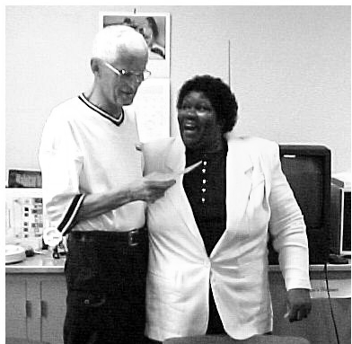
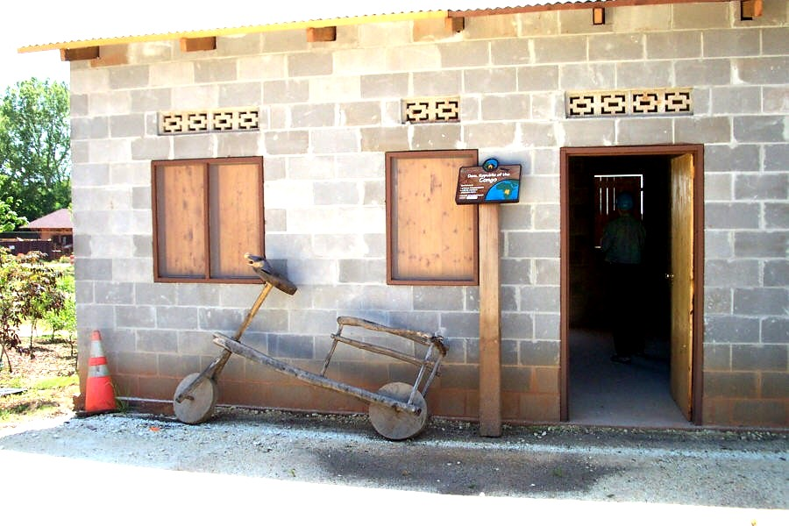

Habitat Board President Elmer Neufeld looks at payoff on Mariah Gibson Hutchins’ mortgage.

Congo house in HfHI’s Global Village

Work was continuing on a Welcome Center that will include much information about the history of Habitat and its work around the world. When the village is completed in 2005 there will be 35 houses including houses from Central and South America, Asia, and Europe. Planned also are demonstration areas where visitors can make bricks, tile, and other building materials like those used to build houses in countries around the world. Also being built is a “marketplace” that will include a photo gallery to tell Habitat’s story through pictures, exhibits, a theatre with film shorts highlighting Habitat world wide work, and a store for purchasing Habitat merchandise, souvenirs, books and clothing.
Board President Elmer Neufeld admires payoff on Mariah’s house, the first mortgage to be paid in full
Finished with the Global Village tour, our guide took us back to the headquarters. We made a quick stop in the small store to purchase several souvenirs and left, driving back east toward I-75. While work at the international headquarters is only a small part of the work of Habitat for Humanity, it serves as the nerve center with connections to hundreds of local affiliates including our own here in Lima. My involvement with Habitat in Lima was enriched by this visit.
Next time you drive south on I-75, think of the connection some 700 miles south. Should you make a trip to some southern destination as we did, drive the 30 miles west to Americus and visit that special place where it all began. You will be glad you did!

Lavon Welty, Board Secretary
First Lima Habitat Mortgage to be Burned
Mariah Hutchins is the first of our Lima Habitat owners to pay off her mortgage in full. She celebrated with the Board at the May meeting, and will celebrate with the whole Habitat community at our block party in July by burning her mortgage at this event. A grateful patient left her a bequest that made this possible, and Mariah now entirely owns her home, the fourth to be built by local volunteers for Habitat. In just a few more years, others of the early homeowners will be doing the same thing, as their mortgages come to an end.

Groundbreaking for Two New Homes
Lima’s Habitat for Humanity is now in the process of building its eighteenth and nineteenth homes in Lima. On April 26, ground was broken by the new homeowners-to-be and representatives of the sponsoring denominations.
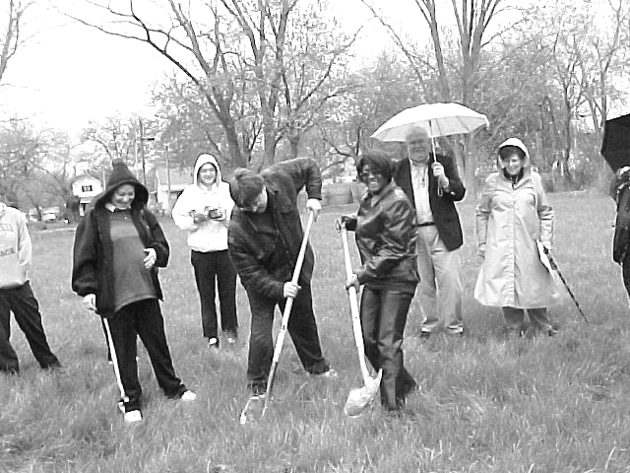
New homeowners break ground as sponsors watch

House number eighteen, to be called the Bishop James R. Hoffman Memorial House, is to be built by the Catholic Collaborative, which is made up of Lima area Catholic institutions, including St. Charles, St. Rose, St. John, and St. Gerard Churches, Lima Central Catholic High School, and St. Rita’s Hospital. This house is part of an ongoing effort by the Collaborative to build at least one house a year in the Lima Area with Habitat. The Hoffman House will belong to homeowner Lynne Hurd.
The other house, number nineteen, to be known as the Methodist House, is being sponsored by the Lima Area Methodist District, consisting of churches in three area counties. That house will belong to the Miller family, Mark, Joyce, and newborn Maranda (born May 30). Mark says that most babies get toys and balls and stuffed animals, but his daughter gets a whole house!
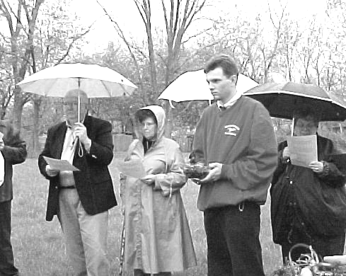
Sponsors participate in the blessing of the property

Lutheran House Dedicated
Ten area Lutheran churches joined together in 2002-3 to build a house for new homeowner Anna Jones and her two grandsons Alundrus Sanders and Jamaree Allen. That house was dedicated on April 26, and Anna moved in. Her house is located at 1031 S. Union, where she will soon have two new Habitat neighbors, Lynne Hurd and the Millers, at 1037 and 1043 S. Union. The dedication was held on a beautiful spring day, well attended by Anna’s family members, Lutherans, the Mayor, and Habitat staff and board members.
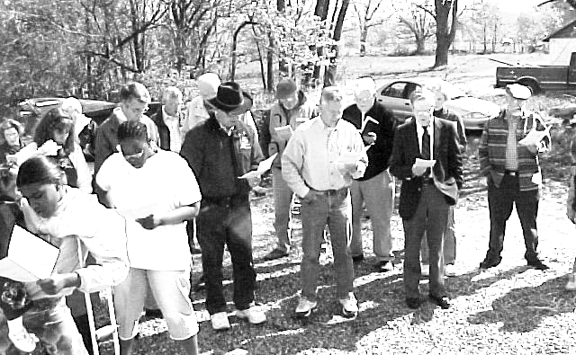

Planning for 3rd and 4th ‘03 Houses Underway
Besides the Catholic and Methodist houses already in progress, planning has begun for the other two 2003 construction starts. Area Mennonite churches are sponsoring one house, and the other will be built in recognition that we now have enough homeowners that their mortgage contributions total an amount approximately equal to one house sponsorship. There may also be a corporate contribution to help. Homeowners will also help with the building. The Mennonite house construction will begin in late July and the homeowner house in the early fall.

Join the Fun at Our Block Party
Mark July 26 on your calendars as the date to attend the Habitat for Humanity—Lima Area, Inc. Reese Avenue Block Party. To be held in the south half of Reese Avenue, where Habitat has now built a total of 11 homes, the party will run from 4:30 until 7:00 p.m. We will be celebrating the completion of the final house in the neighborhood, the progress on two new homes, the burning of the first mortgage, a new groundbreaking and the kickoff of a community-wide Club 1000 campaign.
We invite everybody to come and be a part of our celebration of what has been accomplished and what can continue to happen as we work toward our goal of 30 houses by the end of the 2005 building season.

Club 1000
We still seek persons or groups in the Lima Habitat Area who would be interested in joining Club 1000. Our dream of 1000 individuals/groups pledging to support Habitat for $10.00 per month is still far short of its goal. We have increased our membership, but we have not yet quite reached the point where we could build even one house from these contributions alone. We are kicking off a community-wide Club 1000 campaign, but we will still rely also on our friends and supporters. Remember, 1000 members would generate enough money to build up to four houses each year. Are you being called to join Club 1000? If so, please call the Habitat office for more information (419-222-4937) or mail in your pledge or gift.
