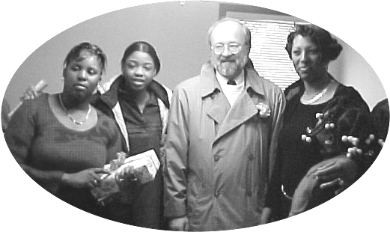

Ken Pulley House Dedicated

Habitat’s Reese Avenue Neighborhood has just expanded by one more simple decent home. There are now 10 of those homes in the Reese Avenue Area, a total of 13 altogether. This one belongs now to the Donna Ingram family, consisting of Donna, her daughters Marquela, 14, and Marcaja, 9, and her son Marshad, 10.
The dedication for the house built in memory of Ken Pulley, former Executive Director of Lima’s Habitat affiliate, was held on Saturday, March 16, in the presence of approximately 50 people. They ranged from the volunteers who helped build it and Habitat personnel and board members to members of Donna’s family and the Ken Pulley family. Representatives from the Board, the City, and the Pulley family spoke, and the home received a blessing from those present and from Pastor Tony Joiner from Phillipian Missionary Baptist Church
The house was funded by the Pulley Memorial Fund, churches and individuals who donated to Habitat, homeowner mortgage payments, the City of Lima’s First Home Program, the Allen Lima Homeowner Downpayment Assistance Program, the Fifth Third Bank, and the Federal Home Loan Bank.
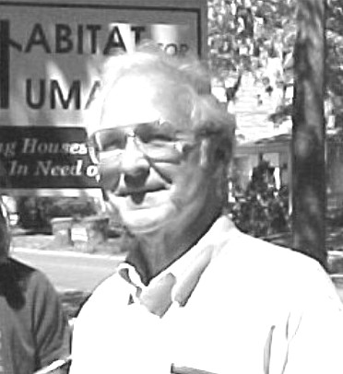
Following the
celebration, a tree was
planted in memory of
Ken, and a stone
will be placed as a
permanent marker. The
house, however, is the
most fitting memorial
for his work and love
of Habitat for Humanity,
and what better place to
build it than Reese
Kenneth Pulley, Executive Director
Habitat for Humanity, 1997-2001
Avenue?

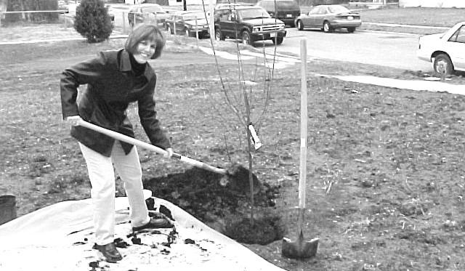

Jean Pulley Canavan helps plant memorial tree

Bluffton College Affiliate Active

In addition to helping build the Ken Pulley house, our Bluffton College Habitat for Humanity Chapter has been busy with activities of its own. In early March, eight chapter members and two adults worked with Green County Habitat for Humanity in Waynesburg, PA, for their Spring Break trip. They assembled interior and exterior walls for over three houses that will be built this spring and summer.
Besides building activities, the students have also been raising funds and awareness. They have had a bake sale, a bowl-a-thon, and an aluminum can collection to raise money, and on April 6 will hold their annual Pancake Breakfast at First Mennonite Church in Bluffton from 7-11 a.m. (Everybody welcome!)
Awareness efforts included their annual sleep-out and contests in hammering and building with aluminum cans recently held as part of Justice Week at the college. Chapter members also plan to participate in Habifest Day, a national day set aside for campus chapter and youth programs to raise awareness through education about homelessness and poverty. One more happening will occur the weekend of the Pancake Breakfast during Little Siblings Weekend at the college, when the students will sponsor an event for small children.
Lima’s Habitat is pleased to have this busy, hard-working group participating in the work of Habitat both locally and on a broader level.

Volunteer Committee Busy During Off-Season

In addition to phoning willing workers to come help build the Ken Pulley House, the Volunteer Committee was also busy last fall updating the volunteer lists. Mike Hanafee, Don Hauserman, and Don McClure (Chair) have contacted each volunteer to inventory the skills and create a new database to allow them to more easily match the skills of the volunteers with the needs of the construction supervisors. However, the new spreadsheet has also pointed out the areas where skilled workers are needed in more numbers than presently available.
To try to fill some of the skill gaps, dialogue is being held with leaders of the electrical and plumbers and pipe fitters unions, and efforts are being made to meet with representatives from the carpenters and painters unions. The goal is to get skilled workers to lead crews on workdays and to train willing but less skilled volunteers so that they can play a greater role.
Are you wondering how you can help Habitat for Humanity—Lima Area, Inc. with its volunteer needs? Call our office, or call Don McClure directly at 419-331-6027 and volunteer your time. Invite us to come to speak to your church mission committee, group, or civic organization. The ways that you can help us are limited only by your imagination. Your church or group could sponsor a workday, or an entire house. You could help us on one of the many committees that needed to make our home building program possible. Give it some thought and some prayer and see where God might lead you to help.

Club 1000
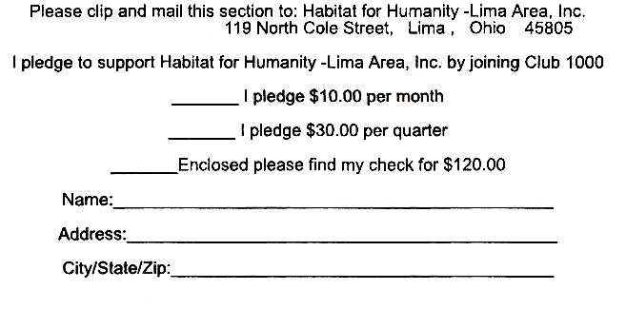

If we are to build four new Habitat houses
this year, we need 1000 people, each donating $10
a month, more than ever! Right now we have
too few members to help fund even a single house.
If we are to meet our goals, we need many more!
Won’t you help us in our mission to
build more simple, decent, affordable homes for
families in need? We have built thirteen now
and would like to put up many more. Only $10 a
month will help a deserving family obtain a home.
Help give a hand up, not a handout, to one of our
new partners.

A Special Thanks to Our 2001 Club 1000 Members
Fred & Mary Amstutz Bryce & Elizabeth Atkinson
Oren & Arleta Augsburger William & Joyce Avery
William Bassett Joan Bauman
Stan and Suzann Bauman T.R. Bauman
Marian Berry Susan & Gerald Biesecker-Mast
Jack Bilen Malcolm & Avril Blair
Mabel Bowers Claude Donald & Elaine Brubaker
CD Group—St. Pauls UMC Virgil & Darlene Coffman
Gail Cook Jo Ellen Cook
Darrell & Peggy Corson Fred & Georgia Cress
Larry & Ginny Cress Jay & Joyce Daniels
Vince & Laura Duckworth Ellen & Royce Engle
Jim & Barbara Fisher Bettye Jo Frail
Virginia Franks Richard & Dorothy Friesen
Grace Frounfelker William & Linda Frueh, Jr.
Bruce & Janet Gelsinger Gil Net Class—Westside UMC
Al & Jane Good Genevieve Graham
Ronald & Judith Hagaman Irene Hamman
Mike Hanafee Ruth Hartzler
Mel & Dottie Hathaway Glennys Henry
Betty Hilty Bruce Hilty
Mark & Marge Hilty Mark & Mary Ann Hilty
George & Elizabeth Hostetler Jerry & Carolyn Huffman
Charles F. Irvin Karen Rust Jarvis
William & Willadeen Keeney Phillip & Judith Kingsley
Wilmer & Glenna Kirkendall Elaine Krietemeyer
Adah Lehman Leland & Dorothy Lehman
Pauline Light Kathryn Luginbihl
Tim & Phyllis Macke Barbara Martin
Hope Mathwig Charles & Carolyn Matthews
Lowell & Muriel Moore A. John & Mary Anne Moser
Robert & Ann Muhler Darryl & Lorraine Nester
Elmer & LaVera Neufeld Dean & Joan Niswander
Wanda Pannabecker Betty Payson
Joan Pulley John & Christine Purves
Wm. Todd Rainey Robert & Alice Ramseyer
Anne Reichenbach David & Margaret Rumisel
Evelyn & Vernon Schmidt John Schneider
Ken & Natalie Shenk Luther & Geneva Shetler
Phyllis Simcox Michael & Charlene Smith
Jerry & Trudi Snyder Willis & Betty Sommer
Pat Sprunger Armeda Spyker
Phyllis Suter Frank Sweeney
Isaac & Margaret Tiessen Betty Troyer
Unity Class—Elm St. Brethren Ed Van Horn
Larry & Sharon Vandemark Judy Waller

Our 2001 Club 1000 Members List Continued

J. Richard & Margaret Weaver Victor & LaDona Wellman
Lavon & Carol Welty Jeffrey Windle
Francis Wisener Robert Wolfe
Arnita Yoder Jon & Jenny Zickafoose
Thanks also to those who have joined in 2002.

Help Us Celebrate at Our Annual Public Meeting

Mark April 22 on your calendars as the date to attend the Habitat for Humanity—Lima Area, Inc. Annual Public Meeting. To be held in the Market Street Presbyterian Church, the meeting will run from 7:00 until 8:30 p.m. During this event, we will review the 2001 Habitat year; thank our sponsors, the many volunteers who helped, the donors, the businesses and organizations that made it all possible; and discuss our plans for 2002.
We invite everybody to come and be a part of our celebration of what has been accomplished and what can happen in the new building season.
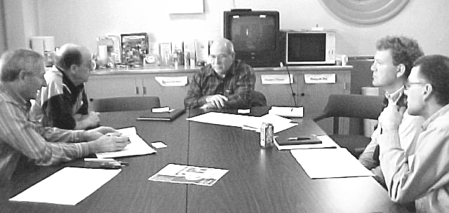

Construction Committee Getting Ready to Build

The Construction Committee, chaired by Mel Hathaway, is preparing for the new building season. They have begun by arranging minor revisions in the drawings in order to make the construction process more efficient. As soon as those revisions are in place, building can begin! Three approved families are now awaiting their chances to get started on their new homes, and hopefully we will see their dreams begin to come true by the end of April.

