Doris Daniel House Dedicated

Habitat’s Fairview Avenue project is now officially half finished. With the completion of Doris Daniel’s new home at 604 Fairview and the partially completed construction of another at 608, the block has an entirely new look. A large vacant and neglected section now has one completely finished house and another coming right along. 604 Fairview was done without the sponsorship of any particular group, so many individual volunteers deserve special thanks. Contingents from Bluffton College, J.P. Timmerman Company, and Celina’s Immaculate Conception Catholic Church were joined by special Habitat volunteers Gary Broughman, Denis Fairburn, Bob Fett, Mike Hanafee, Bill and Dwight Hartman, Les Ingmire, Early Lawson, Don Moritz, Paul Myers, Duane O’Hare, Ken Rozell, Tony Sarno, Don and Heather Shilling, Brent Smalley, Bill Snider, and Paul Stein, as well as a few others.
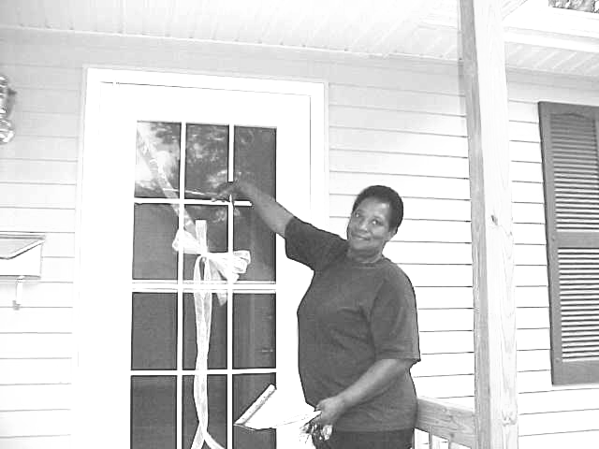

Doris Daniel cuts ribbon at dedication

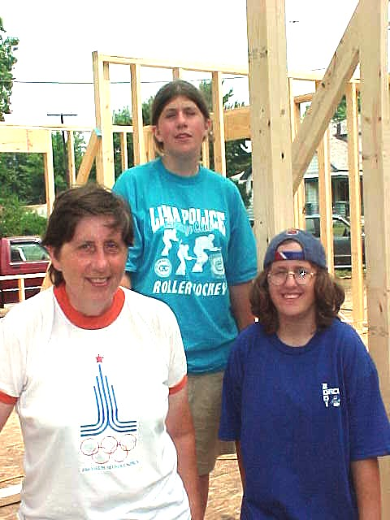

Emilie, Rosie, and Katie Hamman on framing day.

Habitat’s New Construction Manager



Habitat for Humanity—Lima Area, Inc. welcomes Carl Gauthier to the staff as Construction Manager. Carl is a retired engineer from Westinghouse and Sunstrand, where he held positions as manufacturing manager and programs manager. He has been busy in retirement, volunteering to do taxes for senior citizens and work with the city’s Visionaries to provide engineering consulting services for small manufacturing businesses. He has also taken up golf.
Carl’s commitment is to coordinating the building of the Ken Pulley House, currently under construction at 1040 Reese Avenue.

Mennonites Build 2nd House on Fairview

Area Mennonite churches have joined together to provide a new home for Emilie Hamman and her daughters Katie and Rosie. Work began in early July and proceeded very quickly from July until mid-August, when the outside work was 90% finished. Drywall finish work slowed efforts down, but is now complete. This house, now in the finish carpentry stage, reflects the efforts of six churches—First Mennonite in Bluffton, Grace and St. John Mennonite in Pandora, Lima Mennonite in Lima, and Pike and Salem Mennonite in Elida.

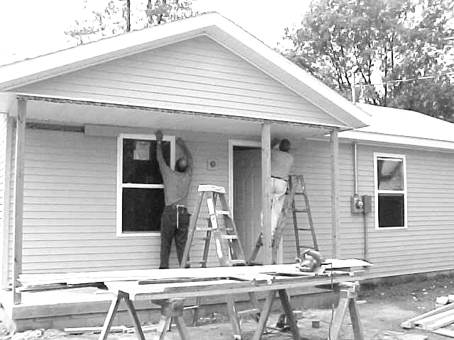

Dwight Hartman and Mel Hathaway work on exterior of the Mennonite House.

Club 1000


We are still a long way from our vision
of 1000 members each giving $10 a month.
Please join us in making dreams come true.
A membership in Club 1000 is a terrific way
to celebrate our 10th anniversary. Don’t forget
that your gift is tax-deductible.
Won’t you help us in our mission to
build more simple, decent, affordable homes
for families in need? We have built eleven now
and would like to put up many more. Only $10 a
month will help a deserving family obtain a home.
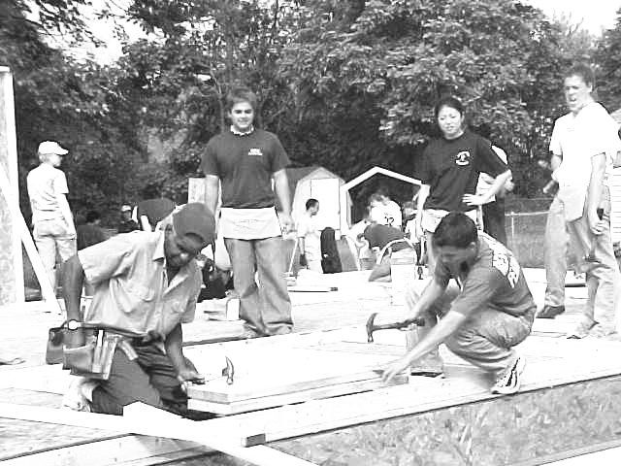

Bluffton College and Bowling Green University students assist volunteers on Pulley House

(Message continued from Page 1)

But the 25th Anniversary Celebration was not only a time of recognizing the phenomenal growth of the vision created by Clarence Jordan and Millard Fuller at Koinonia Farm in Americus, Georgia, in 1976. It was also a time of recommitting ourselves for the years ahead. The proposed goal is to build the next 100,000 houses in five years—1/5th the time of the first 100,000--by 2006! The ultimate goal of which Millard Fuller keeps reminding us all is to eliminate poverty housing and homelessness across the face of the earth!
Habitat for Humanity in the Lima area is just now in the process of completing its 12th house, and beginning the 13th. Can we at least move to the construction of five houses a year, as our part of the goal of 200,000 houses by 2006? How strong is our vision and commitment to help eliminate poverty housing in Lima and Allen County--and with our 10% tithe--also in countries across the world?

Elmer Neufeld, President,
Habitat for Humanity---Lima Area, Inc.

Ken Pulley House Gets Under Way

September 15 marked the first volunteer day for the Ken Pulley Memorial House. Led by Terry Hedges, members of Bricklayers Local #35 built the crawlspace on which the home of the Donna Ingram family will be constructed. They were quickly followed by a crew from Ford Motor Company, coordinated by Mike Marcum, who insulated that blockwork and put on the sub-floor, preparing the way for the September 22 framing day, when the outer walls were framed, sheeted, and erected, with the help of skilled volunteers and crews from both Bluffton College and Bowling Green State University Habitat campus chapters.
Those already involved are just a few of the groups and individuals who have volunteered to get involved with the Pulley House, being built in memory of Former Executive Director Kenneth Pulley. Groups who have already offered or given services and/or donations to be used for this house include the following:
Allen Nott Honda Mazda Toyota staff
Bluffton College Chapter of Habitat for Humanity
Bowling Green State University
Delphos St. John’s High School
Dana Corporation
East Ohio Gas Company
Ford Motor Company Helmig Painting Service
Immaculate Conception Catholic Church, Celina Lima, Allen County, and Oakwood Correctional Facilities
Lima Central Catholic High School
Lutheran churches
Nature’s Call Port-a-John
Rent-All Mart
St. John the Evangelist Catholic Church, Lima
St. Luke’s Lutheran Church ELCA
St. Nicholas Catholic Church, Miller City
St. Peter and Paul Catholic Church, Ottawa
St. Rose Elementary School, Lima
J.P. Timmerman Co.
Waste Management
Webb’s Planning Service

