Winter, 2002
Message from the Executive Director
Judy Waller

Transformations of a Neighborhood

Habitat for Humanity–Lima Area, Inc. has now completed fifteen homes in Lima and is working on two more. Our seventeen house will complete our Reese Avenue neighborhood, making the eleventh home we have put on that street. A recent interview with Ms. Lena Mitchell, age 83 and a forty year resident of her home in the 1000 block of Reese, pointed out the changes that have taken place there.
When Ms. Lena moved there in 1962 with her young son, Reese Avenue was a pleasant place to live, a very quiet neighborhood. It consisted of a number of two story homes, mostly built in the early decades of the 1900's, and inhabited by predominantly elderly people who had already raised their families there. The neighborhood at that time was mixed, with both black and white families. It was a good place to raise a child.
As the elderly families died or moved away, the neighborhood changed, and by the early eighties it was no longer such a pleasant place to live. About twenty years ago, a young man was shot to death in broad daylight just across the street from Ms. Lena, at the corner of the alley where the Lillie Cunningham family now lives. He had earlier in the day broken a window farther down the street, apparently in an ongoing feud with the young man who lived there where the Geneva Williams family presently resides. His life was taken in retaliation for his vandalism.
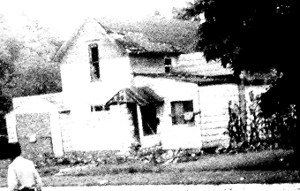
80's era 1051 Reese After-hours place
1037-1051 Reese Avenue today

In between those two houses, where the Jerry and Carolyn Horace house is now, there was an after-hours joint that added way too much drama to the neighborhood. Not only was there drinking with the accompanying noise and fighting, but often there would even be shooting. Ms. Mitchell and her next-door neighbor Ms. Newby often slept in their bathtubs on weekends when it was particularly wild and they feared stray shots. There is a bullet hole on her front porch to this day that testifies to the random violence on the street during that period of time.
As the houses continued to deteriorate, they were demolished one by one. The removal of those homes did not bring immediate improvement to the neighborhood. One particularly unpleasant change occurred just north of Ms. Lena’s house. That then vacant lot was used as an illegal dump by the owner, bringing with it rats and unpleasant odors which made it impossible to enjoy sitting out on the porch.
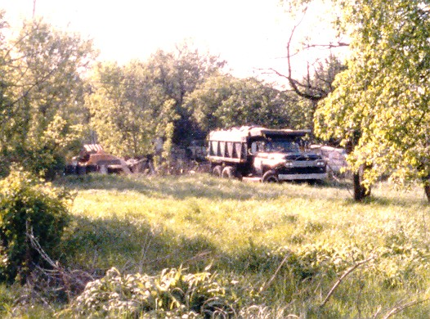

The dump was eventually shut down and cleaned up by the City. The dump trucks, rats, and odors left, but the vacant lots remained, until that day twelve years ago when construction began on the first Habitat house on the corner of Reese and Second, Sue Tucker’s home.
Ms. Lena says she used to pray every night that the neighborhood would come back. She has lived to see it happen. The view from her house is now this, instead of Shorty’s. The neighborhood has returned.

