Fifth Third Foundation Supports Habitat

Habitat for Humanity—Lima recently received a $1500 grant from the Fifth Third Foundation toward three Habitat houses. This grant was part of Fifth Third Bank’s commitment under the Federal Home Loan Bank’s Affordable Housing Program that has been such an important part of funding our local program. We deeply appreciate this partnership with Fifth Third and the Federal Home Loan Bank of Cincinnati.

Family Selection Team News

To help find families, the Family Selection Team has prepared a pamphlet to explain Habitat’s program. After approval from the Board of Directors, the team has been passing these pamphlets out to local churches, social service organizations, clothing pantries, and community oriented police offices.
In June, the Team conducted a two-day Family Selection drive to find families for the 2001 Construction season. Six families applied and the Selection Team is presently reviewing the materials provided. Although one family has already been denied because of too much income for our program, we, as always, gave them other housing options that will help them realize their dream of owning a home.
In July, the Team brought Doris Daniel to the Board of Directors for their approval as our third partner family in 2000. After discussing all the information, the Board approved Doris for a two-bedroom Habitat home, the third to be constructed in 2000.
If you have a burden for people needing simple decent housing, call Don McClure at 331-6027 and learn how you can join our team.

Church Relations Committee Active

The Church Relations Committee has been planning several activities of their own. The committee is working on the next Church Advocate meeting, to be held on Tuesday, October 17. This gathering will include not only Advocates from churches already participating in Habitat’s Club 1000, but also those who might be interested in this easy way of contributing to the work of providing new home for deserving low-income families.
Already planned is our upcoming Block Party Celebration, to take place on Saturday, September 16, in the 1000 block of Reese Avenue. A workday on the two houses under construction will start at 8:00 a.m. , with the tools being put aside at noon so the celebrating can begin. This celebration is a part of Habitat for Humanity International’s “Building on Faith” week and is a chance for everyone to appreciate the new homes and the neighborhood Habitat has established on Reese Avenue, between Vine Street and 2nd Street.
Carol Blass, Chair, Lavon Welty and Roger Miller welcome Nettie Childs and Donna Grant to this committee and invite interested others to call the Habitat office at 222-4937.

New Board Members Added

Not only has Habitat been expanding its neighborhood but the Board has been increasing as well. Three new members have been added in the past year, the first of whom was Ed Van Horn, who came on last fall. Ed is a realtor with the Gooding Co., and he participates in Site Selection. Ed and his wife Penny, who have three grown children, also volunteer with with Square Fair and the Humane Society.
A second recent addition to the Board is Beth Moening, a Consumer/Real Estate Lender with The Ohio Bank with seven years of experience in the mortgage and lending field. Beth has been working with the Family Selection Committee.
The third and latest to be added is Mel Hathaway, pastor at Salem Mennonite Church in the Elida area. Mel and his wife Dottie, a nursing instructor at Lima Tech, have been been in Allen County for five years. Prior to his call to the ministry, Mel was in the constructing and contracting business. He is serving on the Construction Committee.

Bluffton Vacation Bible School Donates

The Bluffton Community Vacation Bible School, comprised of the families of a number of Bluffton area churches, recently held their annual Bible School using Habitat’s “Under Construction” Bible School program. Offerings included tools and toolboxes built as part of the project (see picture of sample) as well as cash and currency totaling almost $175. Students “drained” their pockets into a sink representing the construction of new homes. Executive Director Ken Pulley spoke briefly at the closing program of the week-long event and showed pictures of homes already built and those currently under construction.
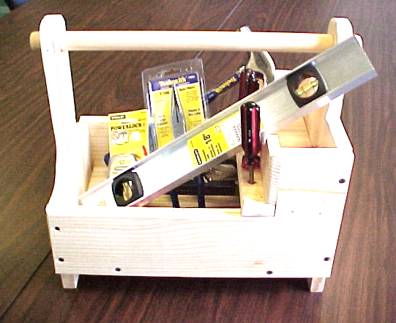

Construction 2000

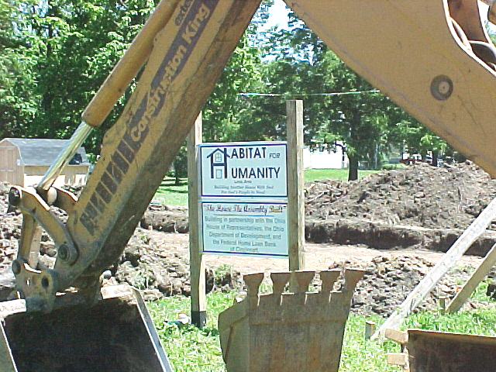
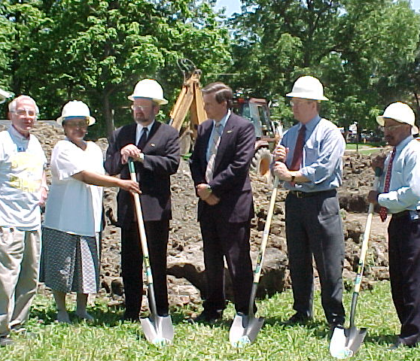
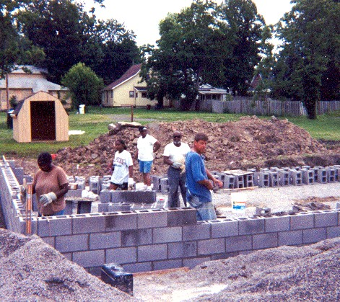
June --Groundbreaking and foundation – 1043 and 1051 S. Reese Avenue
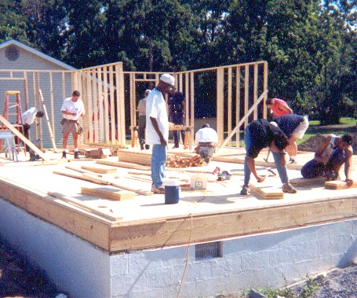
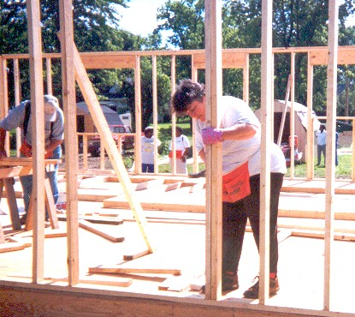
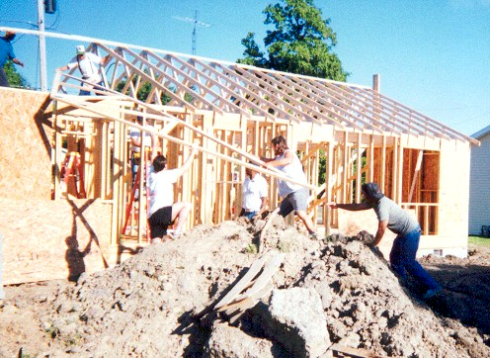
Early July --Framing and sheeting
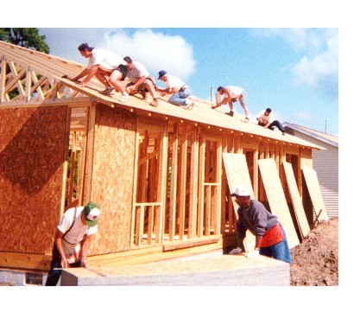
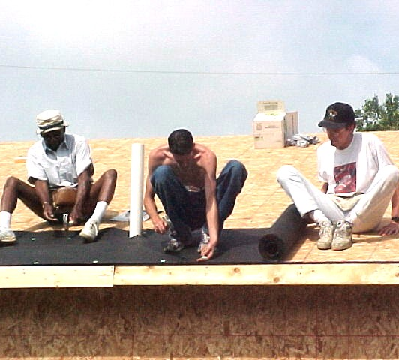
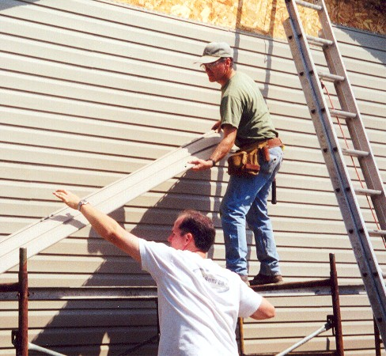
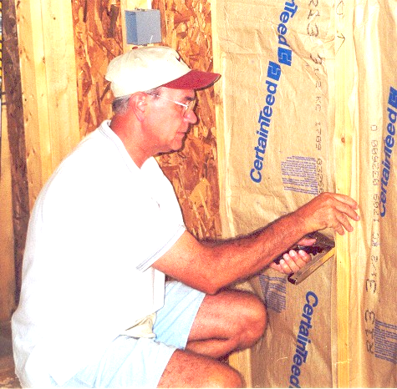
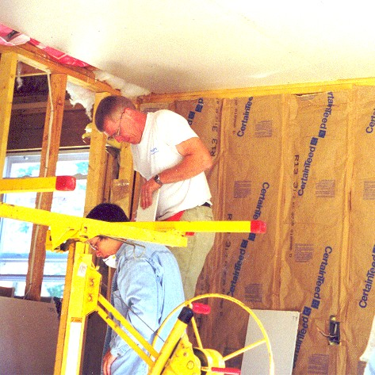
Late July -- Roofing and wrapping
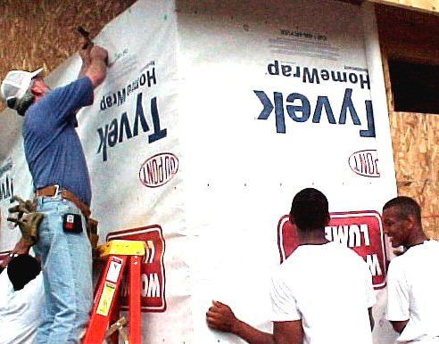
August — Siding, insulating, and dry walling

Club 1000 Memberships Open

Club 1000 is a fund-raising program of Habitat for Humanity—Lima Area, Inc. The Club 1000 members pledge just $10.00 per month throughout the year to support Habitat’s ministry in Lima. With a membership

