Doris Daniel House Nearing Completion
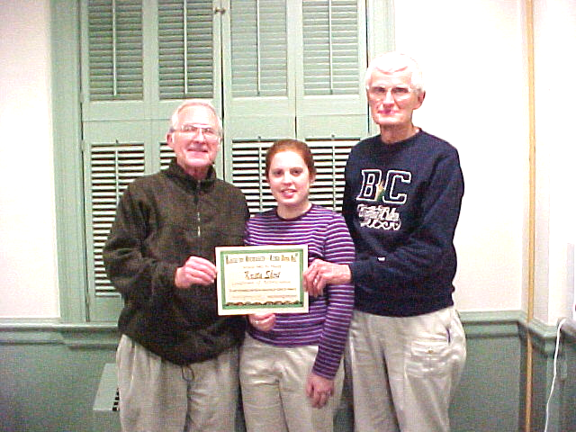

After a very long winter delay, the third home started in the year 2000 is nearing its final stages. This house, started in late fall, was closed in just in time for the heavy snows that delayed further outside construction for several months. Special thanks go to Celina’s work group from Immaculate Conception Catholic Church, Tim Mosher, the J.P. Timmerman Company, and a very special group of faithful Habitat volunteers including Don Moritz, Bill Snider, Bob Fett, Paul Stein, Paul Myers, Les Ingmire, Mel Hathaway, Gary Broughman, Roy Maginess, and Mike Hanafee.
Weather has created challenging conditions for this intrepid group of workers trying to do exterior work—high winds and single digit wind-chill factors, heavy rains and deep mud, in addition to the early heavy snows.
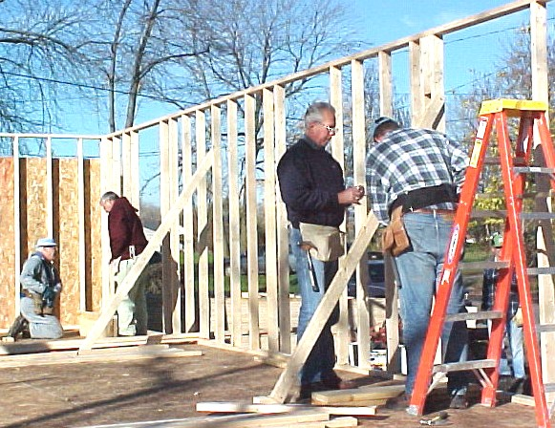

Daniel’s House in November 

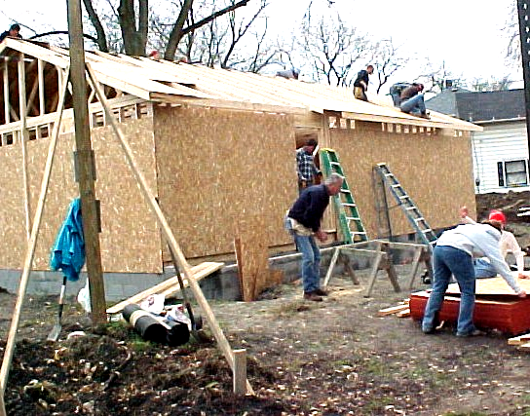

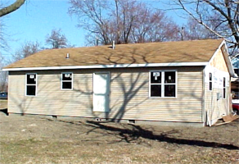

Daniel’s House (rear) in March

Ken Pulley, Krista Short, and Elmer Neufeld

Krista Short Wins Award
The Lima Habitat for Humanity is pleased to congratulate Bluffton College Senior Krista Short for being selected to receive the BSW (Bachelor of Social Work) Student of the Year Award by the Ohio Chapter of the National Association of Social Workers. She had earlier been selected as the BSW Student of the Year by Region One (Northwest Ohio), which made her eligible to be considered for the state award. She received this award because of her activity and leadership in Habitat for Humanity, her summer job at a service organization in Columbus, and other community service experiences.
Krista has been active in Habitat for Humanity in all four of her college years and has served as president of the Bluffton College Chapter since early in her sophomore year. Habitat activities led by Krista include the recruitment of other students for Habitat projects, periodic Habitat fundraisers, the annual on-campus sleep-out in cardboard boxes create awareness of poverty housing, the special spring construction trips to Baltimore in 2000 and North Carolina in 2001, and perhaps most important to us, the periodic work days in Lima and at other Habitat construction sites.

Club 1000
We are a long way from our vision
of 1000 members each giving $10 a month.
Please join us in making dreams come true.
A membership in Club 1000 is a terrific way
to celebrate our 10th anniversary. Don’t forget
that your gift is tax-deductible!
Won’t you help us in our mission
to build more simple, decent, affordable
homes for families in need? We have built
eleven now and would like to put up many
more. Only $10 a month will help a deserving
family obtain a house.

Wanted: Nurturers for Homeowner Families

Lima’s Habitat needs volunteers to become NURTURERS, who are one person or a small group to work with each new Habitat family to enable them to become successful homeowners. This is an excellent opportunity to carry out a Christian mission by being a friend, neighbor, and counselor to the partner homeowner family.
Nurturers learn about the Habitat program and the house to be built, as well as the budget to be worked with and the choices to be made. They then assist the family in making the choices and understanding their commitments and opportunities.

Circle of Hope

In recognition of the Habitat for Humanity International’s 25th anniversary, Ohio’s First Lady, Hope Taft, is sponsoring a circle of 25 Habitat houses to be built in Ohio this year. The Lima affiliate has been chosen to build one of those 25 homes.
Mrs. Taft has been busy gathering support in Ohio for the Circle of Hope project. In addition to soliciting donations, she has enlisted the help of the Ohio State Building and Construction Trades Council who will set up meetings around the state to invite local unions to join us and her in this work. Mrs. Taft will visit each site and expects to swing a hammer with the other volunteers.

Spring Annual Meeting and Rally

April 21 is the date which has been set for the combined Annual Meeting and Spring Rally. The festivities will be held in the Fellowship Hall of Market Street Presbyterian Church beginning with breakfast at 9:00 a.m.
Following the breakfast, all those attending will be given an update, introductions will be made, volunteers and donors will be recognized, and a special speaker will be presented. The meeting will wrap with the awarding of door prizes.
This year’s speaker will be

Habitat for Humanity—Lima
Seeks Construction Manager

Habitat for Humanity—Lima is seeking a part-ime Construction Manager to work with the Executive Director, the local Habitat Board, construction volunteers, vendors and prospective homeowners to build simple, decent, affordable houses.
The position would require approximately 20 hours per week on average, with actual hours depending on the level of building activity. The ideal candidate would be a retired or semi-retired contractor or construction manager with broad experience in residential building and personal commitment to the Habitat mission.
If interested, please submit a resume or statement of qualifications, with references, to: Construction Manager Search Committee, Habitat for Humanity—Lima Area, Inc., 119 North Cole Street, Lima, OH 45805

