Doris Daniel House To Be Dedicated
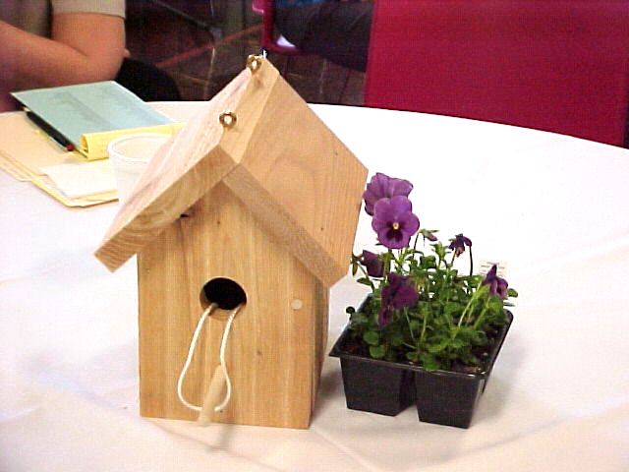

After a very long winter delay and some break-ins to slow progress, the third home started in 2000 is in the finishing stages. Special thanks go to J.P. Timmerman Co. for their donation of time and material, including the Lennox gift of the new furnace in Doris’ home. Other companies who donated generously of services, discounts or money are Webbs Plan Service, Helmig Painting, Rent-All Mart, Nature Calls Port-a-johns, C. J. Baughn Co., Dan the Gutterman, Elida Auto Service, Fifth Third Bank, Whirlpool, Larsen Doors, Yale Locks, ADT Security, Hunter-Douglas Blinds, and Corning Insulation.
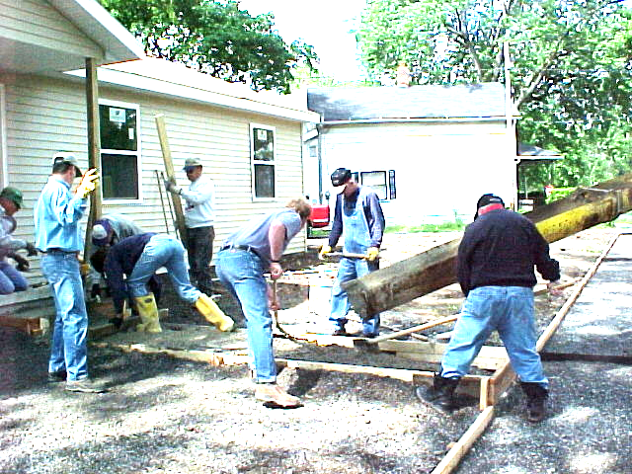

Volunteers pour sidewalk at 604 Fairview home

Habitat Hires Summer Construction Manager
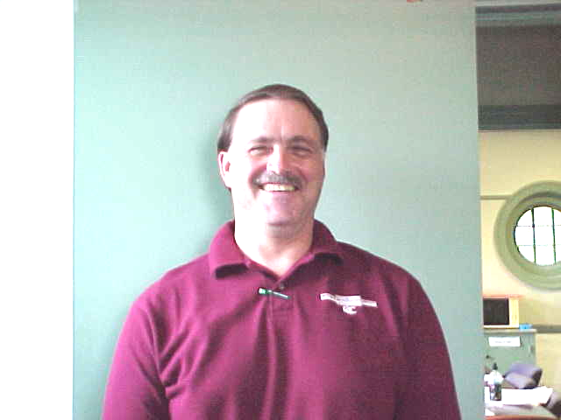

Habitat for Humanity—Lima Area, Inc. welcomes Mark Hollinger to the staff as Construction Manager. Mark has worked with Habitat before as project coordinator for Trinity United Methodist Church for the Lillie Cunningham house built in 1999. He is a student at United Theological Seminary and student pastor at Blue Lick and Ridge United Methodist Churches. Mark will leave us at the end of the summer to return to his ministerial studies, with plans to graduate next spring and receive a more permanent assignment with the United Methodist Church. He has a wife, Kathy, and two children.
Mark is presently seeing to the completion of the Doris Daniel home and is getting ready to assist in the building of two more houses this summer. One of these is to be sponsored and built by six area Mennonite churches, and the other is currently termed the Circle of Hope house.

Methodist Youth Build Birdhouses for Homeowners

As part of their confirmation experience, Methodist youth assembled 25 birdhouses for local Habitat for Humanity families. As part of their Confirmation Adventure, young people gathered for this work project and then departed for a tour of Lima where they were introduced to the mission of several non-profit organizations serving those in need in the area. One of their stops was the Habitat house then under construction, where approximately 100 youth and sponsors learned about the Habitat program. One birdhouse was left at that home, one was decorated and presented to the Ken Pulley family, and the others were given to the other ten Habitat families or stored for future families.

Church Relations Committee

In celebration of the 10th anniversary of Habitat for Humanity of the Lima Area, the Church Relations Committee has been sponsoring appreciation breakfasts for the churches that have been actively involved. Two breakfasts have been held, one in February in the Bluffton Area and one June 16 at the St. Luke’s Lutheran Church, Lima.
The third breakfast is being planned for September 22nd for all churches that have not participated in the previous breakfasts. We hope you will be one who will come for breakfast and share the Habitat story with your local congregation.
The Church Relations Committee is looking for a Church Advocate from each congregation. A person volunteering to partner as a church advocate with Habitat would be a person who:
- Would communicate the story of Habitat to their congregation,
- Would assist in the Club 1000 memberships,
- Provide names from your local congregation of possible volunteers for the build program
- Would commit perhaps two hours a month.

If more information is needed, please feel free to call the Habitat Office at 222-4937 or Carol Blass, Church Relations Chair, at 229-9969

Club 1000
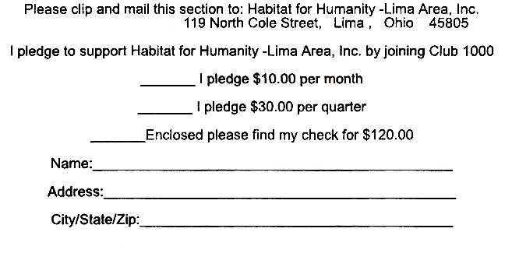

We are still a long way from our vision
of 1000 members each giving $10 a month.
Please join us in making dreams come true.
A membership in Club 1000 is a terrific way
to celebrate our 10th anniversary. Don’t forget
that your gift is tax-deductible.
Won’t you help us in our mission to
build more simple, decent, affordable homes
for families in need? We have built eleven now
and would like to put up many more. Only $10 a
month will help a deserving family obtain a home.

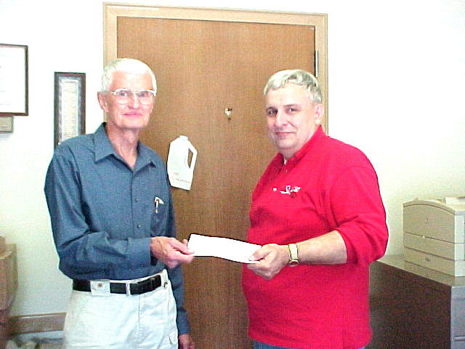
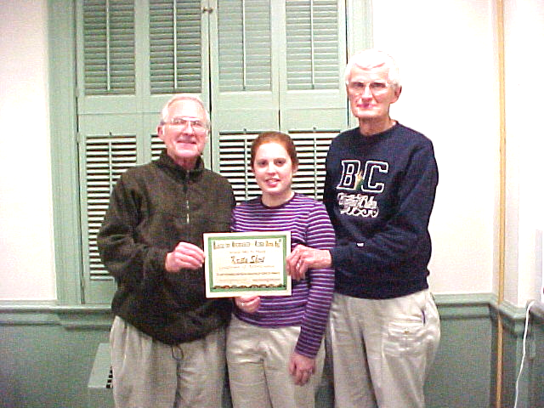

Krista Short Wins Award
St. Rose Principal Ron Huysman presents check to Board President Elmer Neufeld

Young People Donate to Habitat

Lenten donations from two area parochial schools have been presented to Lima’s Habitat for Humanity as a result of the students’ commitment to contributing the money they would have spent on whatever it was they gave up for their Lenten sacrifice. Delphos St. John’s High School donated $445 and Lima’s St. Rose Elementary gave $525, a considerable amount from only 127 students. Another much appreciated donation came from the children (and their families) from The Church of Jesus Christ of Latter-Day Saints. They donated a large number of hand tools that included many hammers, screwdrivers, pliers, tape measures, utility knives, and other items including a wooden tool caddy.



Spring Annual Meeting and Rally

The Lima Habitat Annual Meeting and Spring Rally was held in the Fellowship Hall of Market Street Presbyterian Church on April 21. Those attending were given an update on progress, board members and families were introduced, volunteers were recognized with certificates, with plaques going to some special workers who gave many hours and much leadership to our building projects. Diane Zielger, Habitat Regional Support Manager, gave a short talk remembering Ken Pulley and encouraging everyone to continue his work. Those present gave their own testimonials, and Ken’s children were given a decorated birdhouse (made by Methodist confirmands and decorated by DeHavens) as well as a collage showing Ken in action in numerous settings. Those present were also treated to a sample from the St. John’s Catholic Church production of Joseph and the Amazing Technicolor Dreamcoat.
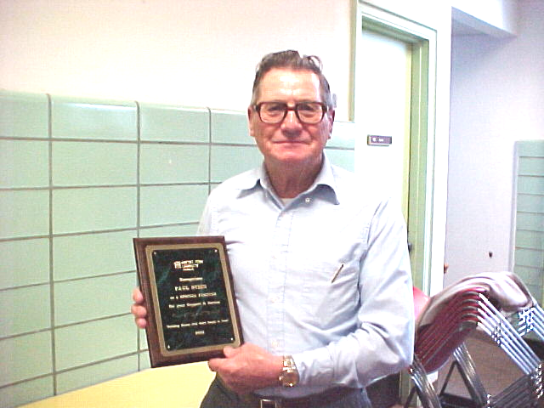

Paul Stein displays award for dedicated volunteer work

Still Needed: Construction Manager Part-time (ave. 20 hrs. a week). Requires some construction experience and good people skills. Call 222-4937 if interested.

