Family Selection Team News

God is great and answers the prayers of those who call upon Him! When the last newsletter came out, the Family Selection Team was struggling to find partner families to bring to the Board for Approval. Now we have two new partner families to introduce to you. In April the Board approved Carol Moore and her son Justin. Since then they have been busy mowing yards, working for Habitat, and earning down payment credit in the First Home Lima program.
At its May meeting, the Board approved the second
Partner family, the Carolyn and Jerry Horaces. Since then they too have signed up for First Home Lima and have started accumulating down payment credits. On Saturday, May 20th, Jerry and family members helped pass out Habitat fliers to tell more Lima area neighborhoods about our program. This is a family in which Habitat and the Family Selection Team take great pride. They have made substantial sacrifices and progress over the past four months to quality for their Habitat home.
Team member Laura Duckworth and her husband Vince are the proud parents of a new baby boy named Samuel Paul Duckworth. Laura reports that Samuel is doing well and gaining weight.
We would also like to introduce a new Team member. Beth Moening is a Consumer/Real Estate Lender with the Ohio Bank. Beth joined the Family Selection Team in May and is already reviewing our materials to familiarize herself with what we do. If you would like to join our Team, call Don McClure at 331-6027 and volunteer your services.

Site Development Committee Hard at Work

The Site Development Committee, with the able assistance of Executive Director Ken Pulley, continues to acquire property. We have purchased several lots in the Vine and Scott Street area, and on Union Street have been donated two lots by the Van Scoder and Gossard families and two more lots by Jethro and Rhonda Montgomery. All together, we have space for seven more families.

Nurture Committee Building Community

The Family Nurture Committee continues to meet monthly with homeowners. As the weather heats up, so do neighborhood issues. Homeowners have been discussing community and safety concerns—speeding traffic, littering, loud noise, and congregating. This group has been meeting with law enforcement officials to work out a plan of cooperation in dealing with mutual concerns. Additionally, homeowners are interested in security and lawn maintenance. They will be talking with a security company about alarm systems. Also, committee member Don Hauserman has been teaching interested owners how to do small maintenance repairs. This group continues to be very important in the Habitat community. With two new families building houses this summer, the committee does have an urgent need for a new nurturer for each of these families. If you are willing to donate your time and get involved with a family, call the Habitat office and we will put you in touch. 222-4937

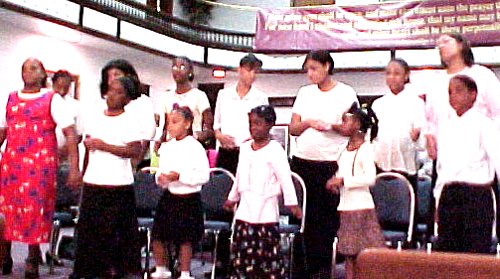
Mt. Olivet Choir

Church Relations Committee Active

Another group hard at work, the Church Relations Committee held two events. The first ever Spring Rally, on Sunday, April 30, at Holy Tabernacle, drew a small but very enthusiastic audience. Highlights of the afternoon were the singing of the Mt. Olivet Church of God in Christ choir and the presentation of special guest speaker Leroy Troyer. His slides and remarks about the work of Habitat affiliates both in the United States and overseas were quite inspiring to those fortunate enough to hear them. The second meeting was for Club 1000 Advocates, whose work continues to be important to the local Habitat organization.
Carol Blass, Chair, Roger Miller, and Lavon Welty invite interested others to join this committee by calling the Habitat office at 222-4937.

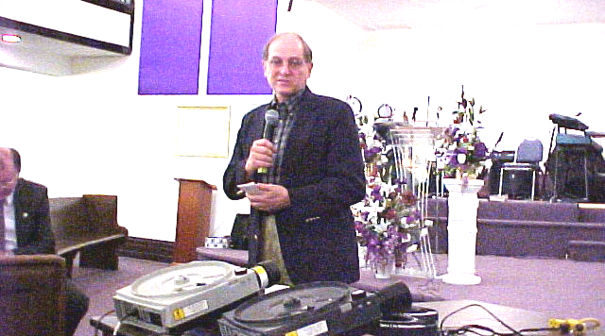

Leroy Troyer

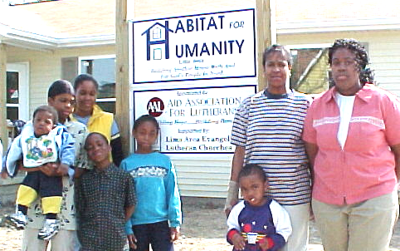
The Geneva Williams family

Club 1000

Needs You! Join Today

Eighth House Dedicated

The home Habitat volunteers worked on all winter has been completed and turned over to the Geneva Williams family. The home, sponsored by the Aid Association of Lutherans, with the able assistance of area Lutherans, was dedicated on April 29. The new occupants are Geneva, her sons Tyler, daughters LaShawna and Charnell,, grandson Dre’Ton, niece Jessica, and nephews Aaron (not pictured), Alonzo, and Justin. Geneva, is employed by the Philips Display Component Company.
She is enjoying her new home and is grateful for the efforts of the volunteers
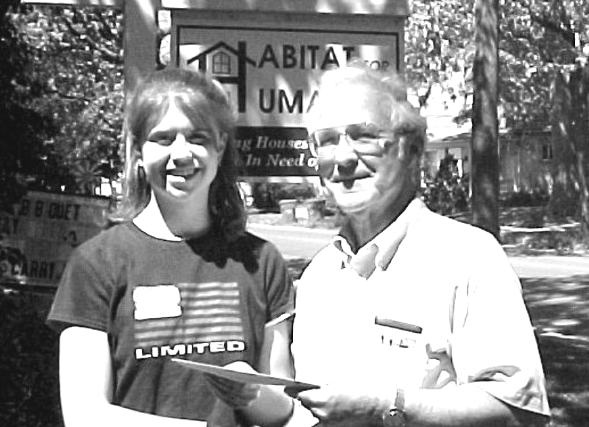
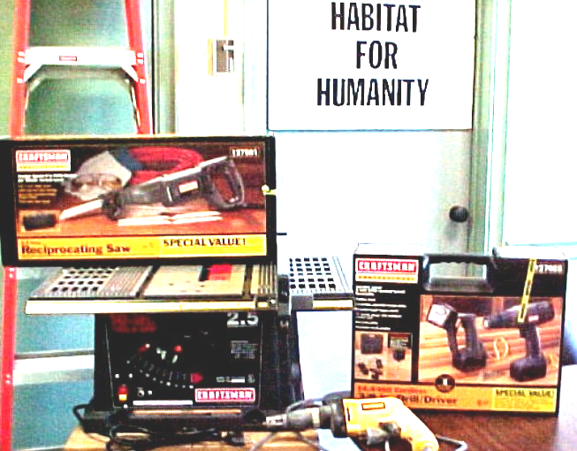

Paula Davies, Octagon Club, presents check
Power tools from Bluffton M.S. donation

Building Continues

Even when Habitat has no new homes under construction, the volunteers build anyway. One new shed is already up and another is ready to go, thanks to the efforts of enthusiastic workers. Warm humid June Saturdays did not keep the volunteers from Ford Motor Company, the Allen East Ewes and Rams 4-H members, and the St. Paul United Methodists from contributing their labor to get these sheds ready for the homes that will be built at 1043 and 1051 Reese Avenue this summer.

Schools Donate to Habitat

Habitat for Humanity—Lima Area has benefited greatly from the generosity of area schools in the past several months. In addition to the $900 donated by the Bluffton Middle School 6th Grade from their fundraiser (for purchase of power tools), we received a tool box and hand tools from West Middle School, as well as $153 collected from students. From Wapakoneta High School, the Octagon Club, a group of community-service oriented students, presented us with a check for $500. Our affiliate is certainly blessed to have these generous, public-spirited young people contributing to us.
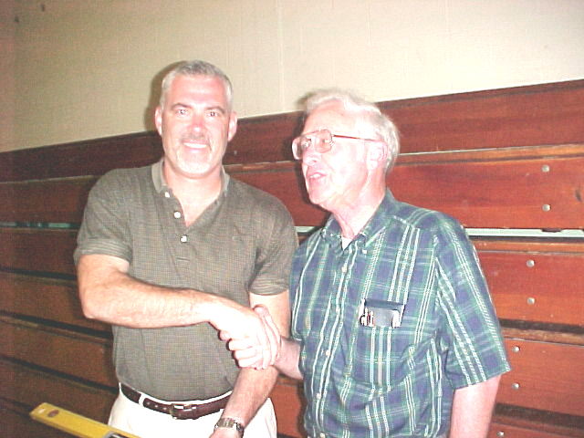

Jon Zickafoose presents West M.S. contribution

New Truck Looking for a Sponsor

Habitat for Humanity—Lima Area has recently acquired a pickup truck for use in construction. It is a red 1987 Chevy S-10 with an extended bed. It is far from new, but it’s in good condition and fulfills a wish that has been on our list. Is there anyone out there who would like to donate to cover the cost of the vehicle ($2000) and/or cover maintenance costs? Also, it would be even more useful if it had a cap? Anyone willing to donate one?

