Making a Difference
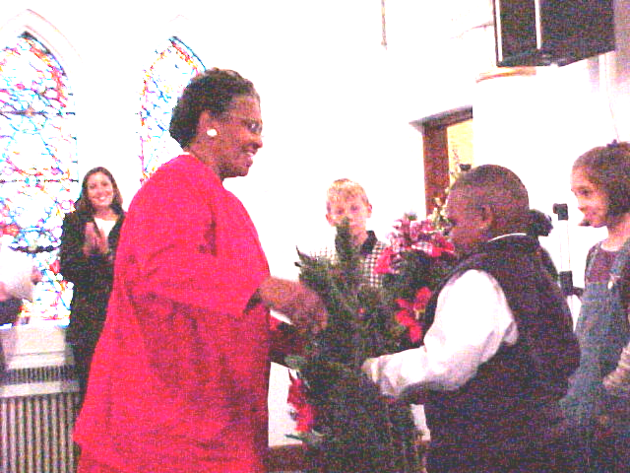

Make a Difference Day, October 28, made a big difference in the sites of two Habitat homes and gave a start to the third house to be built this year. Students from

the Bluffton College Campus Chapter of Habitat for Humanity painted the sheds for both houses and, with the donations and assistance of DeHavens Home and Garden, landscaped one of them (returning the following Saturday to landscape the other). A crew from Ford Engine Plant was also busy that Saturday, building the shed for the home now under construction at 604 Fairview. We appreciate both of these volunteer groups, as well as all of the wonderful churches and organizations that make Habitat homes a reality.
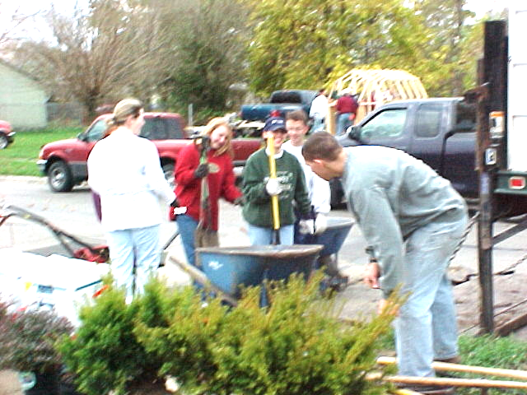

Bluffton Students Hard at Work Landscaping

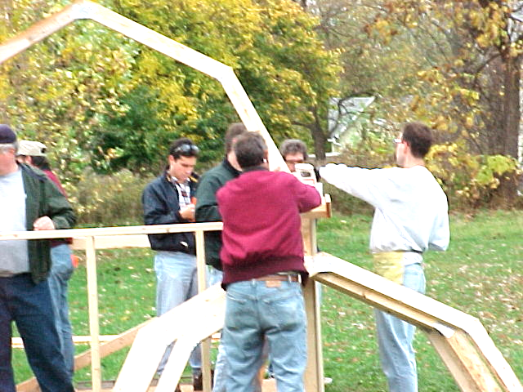
Ford Engine Builders Put up Shed

Dedication Ceremonies Held
November 18 was a very special date in the lives of two families. Carol Moore, Jerry and Carolyn Horace, and their families received the keys to their brand new homes at 1043 and 1051 Reese Avenue. The dedication ceremony was held at the Mount Olivet Church of God in Christ and was attended by almost 100 people. John Willamowski, JoAnn DeHaven and contest winners, Ken Pulley, and Marilyn Taylor made presentations of certificates, keys, tools, decorations, and Bibles. A blessing and open houses followed at the new homes.

Tyreeke Hicks Presents Wreath to Carol Moore

DeHaven Contest Winners Make Presentations
At the November 18 dedication of the homes of the Carol Moore and Jerry & Carolyn Horace families, winners of a DeHaven’s sponsored contest presented the new homeowners with holiday wreaths and table decorations. Students wrote essays or drew pictures on the subject of what makes their homes special. Winners in the kindergarten through second grade with drawings were On’yae Jones and Tyreeke Hicks, both first grade students at Whittier Elementary. Winners in the essay category, third grade through fifth, were Lacie Hale and Shane Wilgus, fifth graders at Irving Elementary.
Homeowners also received the framed prize-winning drawings to hang in their new homes. In addition to making the presentations, DeHaven’s has been exhibiting the artwork and literary efforts as part of their holiday display, which features Habitat for Humanity—Lima Area, Inc. DeHavens also supplied the landscaping for the two houses just completed. We are very pleased to have them partnering with us in so many ways.

Family Selection Team News
Our team had two Family Selection Drives this quarter: the first on Thursday, Nov. 9th and the second on Saturday, Nov. 11th. The results of these 2 drives were disappointing at best. A total of three people showed up, and none of them are likely to become our next partner family.
Because of the limited turnouts at our drives, we have been discussing expanding our outreach to include many of the smaller churches south of Market Street. A total of 55 to 60 churches could be added to the 50 churches, neighborhood associations and social service agencies that we already contact prior to each drive. Hopefully this will increase the number of families that we can reach. One bright spot is that Head Start requested 600 of our new Family Selection pamphlets so that they can mail them out to all of their families. We really need your prayers if things are going to change. We also need your presence on our Team so that we can expand our one-on-one contact with area pastors.
Continud on page 3

Club 1000

As the year 2000 winds down, it
is not too late to make your annual
contribution to Club 1000 for this year, and
it is also a terrific way to begin 2001. Don’t
forget that your gift is tax-deductible!
Won’t you help us in our mission
to build more simple, decent, affordable
homes for families in need? We have built
ten now and would like to put up many more.
Only $10 a month will help a deserving
family obtain a house.

Prayer of Thanksgiving
As we approach the end of another wonderful year that the Lord has given us, it is appropriate that we take time to give thanks for the many blessings He has bestowed upon us.
Thank you, Lord, for giving us the opportunity to do your work through Habitat for Humanity.
Thank you, Lord, for our volunteer Board Members who provide counsel and guidance in carrying out Your Work.
Thank you, Lord, for bringing us deserving partner families who have shared in our work and moved into new homes this year—Geneva Williams, Carol Moore, and Jerry & Carolyn Horace, and their families.
Thank you, Lord, for the many wonderful volunteers who have labored to complete three houses and start a fourth.
Thank you, Lord, for the Area Churches that have supported Habitat with their prayers, their people, and their resources.
Thank you, Lord, for the many generous individuals and organizations who provide the financial support that is so essential to our Mission to work with your people in need of simple, decent homes. Whenever there is a need, You always provide the way to meet it.
Thank you, Lord, for the many local and national businesses that generously support Habitat with outright donations or special pricing that makes it possible to build affordable homes for those in need.
Ken Pulley, Executive Director
Personal note: I want to thank my Habitat friends, family, and medical caregivers for the prayers and support that have sustained me through a year of chemotherapy and radiation treatments. If we have not won the battle with cancer, we are at least holding our own. With your continued support and God’s continued blessing, I look forward to another year of opportunity to serve in His Work.

J.P. Timmerman New Habitat Partner
On November 27, 2000, Habitat for Humanity—Lima Area, announced a working partnership with J.P. Timmerman Company, who will provide plumbing, heating, and electrical services on its new house at 604 Fairview Avenue. This house, which was started in early November, is Habitat’s third house this year.
The services to be donated by Timmerman’s will be a big help in getting this house completed during the winter months; Habitat is very grateful and looks forward to this working partnership. We work with families in need of simple, decent, and affordable housing, and cannot carry out our mission without the support of generous partners. The new house is closed in and under roof, and J.P.Timmerman started its work on November 30 as part of its service to the community.
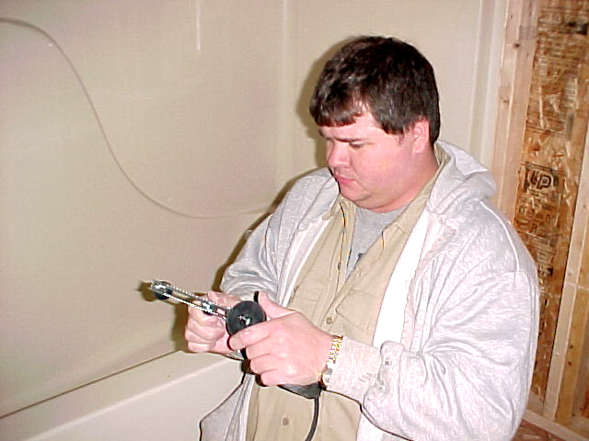

.

Timmerman’s employee Bill Miron installs plumbing

Continud from page 2—Family Selection Team News
In between Family Selection Drives, we have been busy updating many of the materials we use. Recently we finished the revision of the outline telling how we work. Presently we are updating our Letter of Acceptance that we sign with all of our families prior to starting work on their houses. We are considering the incorporation of some new ideas from Habitat Regional. One item that we will include is a basic house description listing the sizes and standard features for all of our homes.

