Announcing:
Habitat for Humanity, Lima Area Incorporated Annual Meeting
Tuesday, April 27, 2004, 7:00 p.m.
Market Street Presbyterian Church Fellowship Hall

Construction Committee

Work continues on the two houses currently under construction. The “Mennonite House” being built for the Kelley family is nearly finished. The “punch list” for the interior of the house includes only minor items anymore and the house awaits final inspection as these are completed. As Spring weather arrives the exterior tasks will be tackled such a sidewalks being poured and the lawn graded and seeded.
The “Sprint/Homeowner” house being built for the Evans family is also making good progress. Work already completed in the past several weeks includes rough in plumbing and electrical, and the siding has been installed. At present the volunteers are busy putting up the sheet rock. When this is completed work will start on finish drywalling. The next major project on the exterior will be building the deck. No date has been set for completion and dedication.
The Construction Committee is also making plans for the 2004 construction season. The next house will be built on the lot next to the Mennonite House on South Scott St. Lot preparations are being planned including the removal of several trees after which excavation will begin.

House Dedication

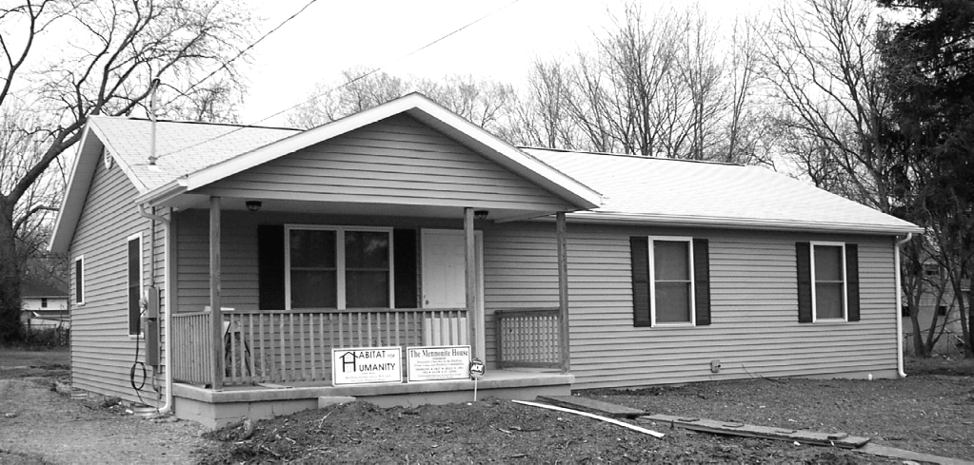

The house built for the Kelley family at 1015 S. Scott St. in Lima was dedicated Saturday, April 3. Sponsored by area Mennonite Churches, only the exterior work of landscaping and sidewalks remain to be finished as weather permits. The dedication program included an introduction of the partner family and words of deep appreciation to the representatives of the churches present for helping make home ownership possible. The house is the twentieth house built by our affiliate.

New Book by Millard Fuller

This most recent book by Millard Fuller, founder and president of Habitat for Humanity International has recently released. It is filled with 40 new essays with inspirational messages sure to motivate and inspire readers of any age. The book’s timeless stories include important morals and life lessons that will be a blessing to all who read them.

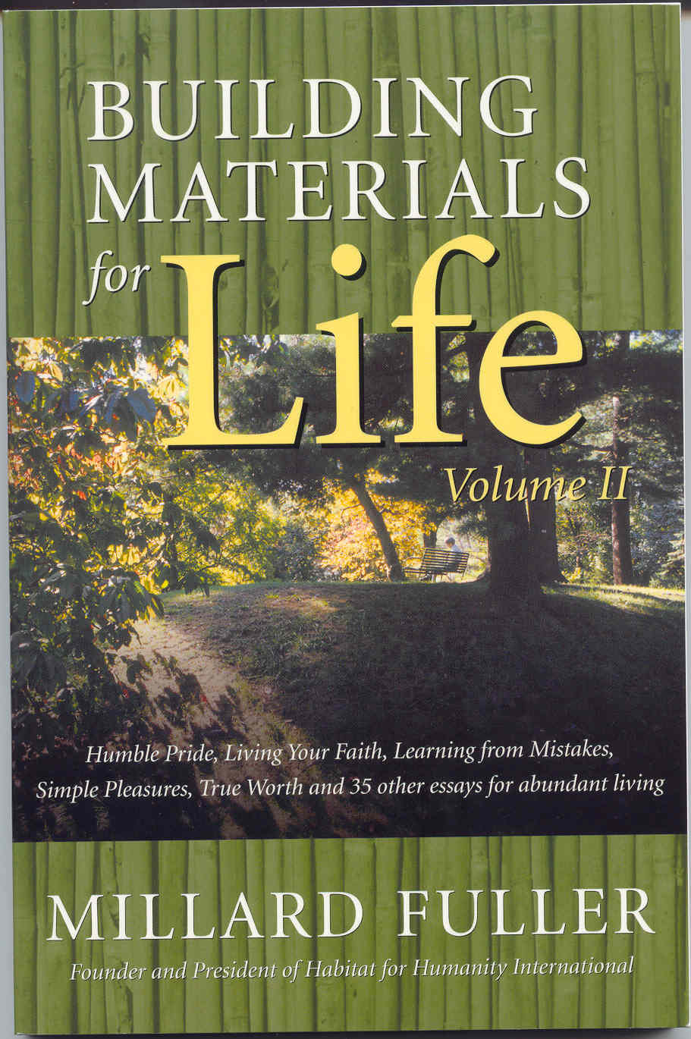

Church Relations Committee

The Church Relations Committee is arranging for the hosting of youth groups coming to Lima this summer in four successive weeks in July-August. An experimental program of Habitat for Humanity International, our affiliate was asked to pilot this program that will bring to Lima youth groups for a week of service and learning beginning July 11.
While the Construction Committee is planning for the youth to work on housing construction projects for those 16-18 years old, the Church Relations Committee is arranging for those younger to volunteer with other agencies in Lima. Housing will be in the Trinity House, a retreat facility operated by Trinity United Methodist Church in Lima.
Volunteers will prepare breakfast and evening meals while area churches are being asked to provide noon lunches. Several restaurants have indicated interest in providing a meal for the groups. Two nights during each week the committee is arranging interaction with local church youth groups.
Recreation options are also being planned including a picnic and swimming at the Ottawa Metro Park and a field trip to the Neil Armstrong Air and Space Museum in Wapakoneta.
The Mayor’s office has indicated openness to meet with each group early in the week as part of their orientation to the city and surrounding area. A staff person from the Habitat for Humanity International office will be present to assist with the groups and lead devotionals and other focused learning experiences.
The Church Relations Committee is excited by the prospect of hosting the groups in their pilot program. At this point we have no idea where the groups will come from but we anticipate that they will receive a warm Lima welcome when they arrive!

Club 1000

We still seek persons or groups in the Lima Habitat Area who would be interested in joining Club 1000. Our dream of 1000 individuals/groups pledging $10.00 per month is still far short of its goal. We have not yet reached to point where we could build a house from these contributions alone. 1000 members would generate enough money to build up to four houses each year. Are you being called to join Club 1000? If so, please call the Habitat office for more information (419-222-4937) or mail in your pledge or gift.

Thank You for These Club 1000 Members in 2003



Adult SS—Elm St. Church
Of the Brethern
Don Ammon
Fred & Mary Amstutz
Oren & Arleta Augsburger
Ruth Ayers
William Bassett
Sam & Barbara Bassitt
Eric Basinger & Iris Neufeld
Joan Bauman
T.R. Bauman
T.R. & Barbara Bauman
T.R. & B. Bauman Children
Stan & Suzann Bauman
William & Sheila Benson
David & Linda Berger
Marian Berry
Susan & Gerald Biesecker-Mast
Jack Bilen
Gary & Marilyn Bishop
Karl & Carol Blass
Otto & Bette Bollenbach
Claude Boyer
Mary Boyer
Andy & Ada Brenneman
Clara & David Brenneman
Jane & Lawrence Brown
Don & Elaine Brubaker
Glenn & Judy Buller
CD Class of St. Paul UMC
Christian Comrades—Grace UMC
Franklin Cooley
Fred & Georgia Cress
Larry & Ginny Cress
Jay & Joyce Daniels
James & Wilma Davis
Josephine Derryberry
Elizabeth Eley
Ellen Engle
Royce Engle
Bob & Sue Fett
Francis Fettig
John C. Fisher
Virginia Franks
Richard & Dorothy Friesen
Grace Frounfelker
Tom & Geraldine Frueh
Howard Garber
Bruce & Janet Gelsinger
Gil Net Class-Westside UMC
Al & Jane Good
Grace UMC—St. Mary’s
Genevieve Graham
Ron & Judy Hagaman
J. Irene Hamman
Mike/Ellen Hanafee
Dwight & Virginia Hartman
Mr. & Mrs. Marvin Hartman
Ruth Hartzler
Mel & Dottie Hathaway
Patricia & Dean Hawk
Don Houserman
Grace Heaston
Glennys Henry
Marjorie Hollinger
George & Elizabeth Hostetler (2)
Jerry & Carolyn Huffman (2)
John & Lorraine Ignarsky
James & Sandra Imbrock
Ralph & Lisa Joseph
William & Willadeen Keeney
Harry Kim
Mitchell & Ann Kingsley
Phillip & Judith Kingsley
Wilmer & Glenna Kirkendall
Leland & Dorothy Lehman
Jerome & Anne Liebrecht
Pauline Light
Millie Lugibihl
Kathryn Luginbill
Tim & Phyliss Macke
Barb Martin
Hope Mathwig
Mary McCarthy
Rod & Carolyn McDaniel
Bud & Sheila Miller
Steven Miller
John & Mary Ann Moser
Stan & Ruth Naylor
Darryl & Lorraine Nester
Elmer & LaVera Neufeld
L. Lamar & Deborah Nisly
Dean & Joan Niswande
Pike Mennonite Primary
Ernest Porzelius
Joan Pulley
John & Christine Purves
Jim & Pam Raabe
Wm. Todd Rainey
Robert & Alice Ramseyer
Anne Reichenbach
Richard & Mary Repasz
David & Margaret Rumisel
Kathy Ryan
William Scherger
Charles & Barbara Schierloh
Robert & Marilyn Schmerge
Vernon & Evelyn Schmidt
Jim & Mila Schawbero
Elizabeth Shelly
Ken & Natalie Shenk
Luther & Geneva Shetler
Michael & Charlene Smith
Delbert & Lela Snyder
Willis & Betty Sommer, Jr.
Jim & Becky Sprunger
Ted & Kate Stepleton
Bill & Donna Suter
Bob & Joyce Suter
Phyliss Suter
Russel & Jean Suter
Chuck & Imogene Swartz
Irene Swartz
Earl & Marilyn Taylor
Russ & Barbara Taylor
Isaac & Margaret Tiessen
Bob & Jean Tomlinson
Betty Troyer
Ed Van Horn
Larry & Sharon Vandemark
Joe & Connie Voss
Wapak UMC Christian Couples
Randy & Dawn Wapperom
Richard & Alice Warren
J. Richard & Margaret Weaver
James & Jane Webb
Lavon & Carol Welty
Robert & Jane Williams
David & Susan Wilson
Francis Wisener
Robert Wolfe
DaVilla Workman
Jeff & Kim Wright
Arnita Yoder
John David Yoder & Lynda Nyce
Curtis & Linda Young

Our apologies to anyone we missed inadvertently or who gave to Club 1000 through their churches, which may not have supplied us with their names.

A big, heartfelt thanks too goes to all of our very generous individual and organizational donors, who may not belong to Club 1000 but are not less appreciated! It is with your help that we can build four houses a year.

Thank You!

$500+ Individual Contributors

Stan & Jonenita Clemens Leo Hawk
Eric Basinger & Iris Neufeld Oliver & Pat Lugibhil
Carl Gauthier Ron & Sue Spencer
William & Mary Tripplett Tom Ahl
Therese Saggau & Danny Drotos Marian Berry
Barb Martin Judy Waller
Larry & Ginny Cress

