Union St. House Dedications
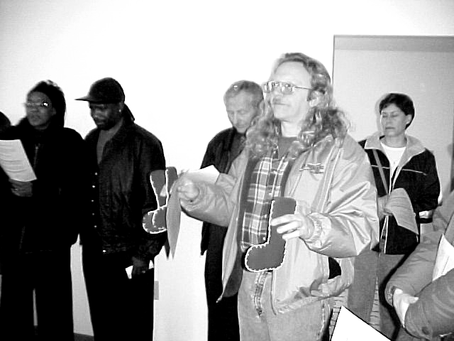

House dedications rarely happen on two successive days. But our affiliate experienced dedications on Saturday, December 6, and Sunday, December 7. The first was the house sponsored by the Catholic Collaborative with the Hurd family in memory of Bishop James R. Hoffman of the Toledo Diocese. In a ceremony coordinated by Sister Teresita of LCC, the house was blessed and a memorial plaque was dedicated.
Then the next day, the house next door was dedicated. Sponsored by area United Methodist churches with the Miller family, the dedication included singing and prayers, a litany of dedication and comments of gratitude from the Millers. Unique in this dedication was a special blessing symbol attached to the porch column by United Methodist District Superintendent Thad McGehee.
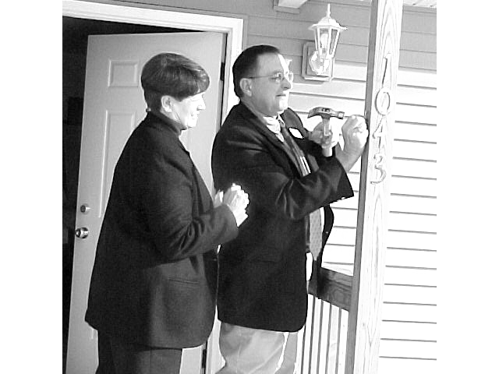

(Continued from p. 2)
Continuing Board Members are Lavon Welty, Board Secretary and Chairman of the Church Relations Committee; Marilyn Taylor, Chairperson of the Family Support Committee; Anthony Okuley, Board Treasurer, responsible for financial reports and budget; Ed Van Horn, Board Vice President, and Chairman of the Site Selection Committee; Mel Hathaway, Chairman of the Construction Committee; Geneva Williams, Homeowner, and member of the Family Support Committee.

ElmerNeufeld
Board President

Site Selection Committee
The site selection committee continues to support the organizational goals by acquiring lots on which to build future homes. In recent weeks, the committee has obtained commitments from the city for several lots in the McKibben and Pearl Street area.
Additionally, the committee has obtained several lots at Fairview and Erie Streets and is acquiring more there. With two houses already nearby on Fairview, these acquisitions will enable the development of a community with up to eight houses.
Coordination continues with the County Prosecutor’s office to obtain three lots at the corner of Perry and High streets. As the year 2003 comes to a close, the committee is optimistic we can meet the goals for 2004 with lots available on which to build future homes

Annual Christmas Dinner
The Lima Habitat family gathered on Thursday, December 11 for its annual Christmas dinner. More than 60 persons representing homeowner families, staff, board and committee members gathered in the Fellowship Hall of the Market Street Presbyterian Church to eat, celebrate, and sing together the songs of Christmas. Church Relations Committee member Lorraine Ignarski provided turkey supplemented by an array of delectable hot dishes, salads, and desserts provided pot luck. Executive Director Judy Waller ended the evening with a review of the Affiliate’s efforts in 2003.
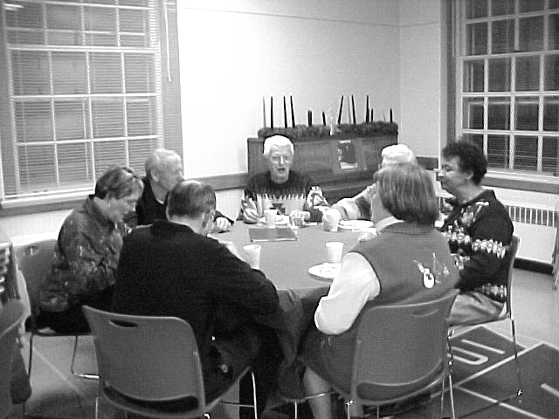

Club 1000
We continue to seek persons or groups in the Lima Habitat Area to join Club 1000. Our dream of 1000 individuals/groups pledging to support Habitat for $10.00 per month is still short of its goal. Remember, 1000 members would generate enough money to build up to four houses each year. We are also looking for members for a Super 100, individuals, businesses or institutions willing to donate $1200 a year (25 of them would pay for a house). Are you being called to join Club 1000 or to move to the Super 100? If so, please call the Habitat office for more information (419-222-4937) or mail in your pledge or gift.

10,000 Villages Sale
For the second year in a row, the Et Cetera Shop from Bluffton sponsored a sale of 10,000 Villages items at Market Street Presbyterian Church, to benefit Habitat for Humanity. Items in the sale are Fair Trade crafts that pay a fair price to the cottage industries that produce them, at the same time providing unique and interesting gifts. The sale was held November 13-15 in the Fellowship Hall.
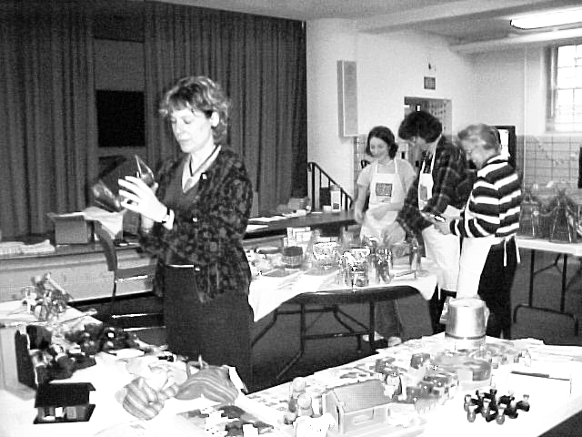

Church Relations Committee

The task of the Church Relations Committee is to offer members of area churches a range of ways to give their time and talents to the immense task of eliminating poverty housing in our community. Our affiliate recently was challenged by Habitat for Humanity International with two new exciting possibilities for involvement.
The first is a program labeled “Building on the Dream,” a concept rooted in the dream of Dr. Martin Luther King, Jr. This program is aimed to foster greater involvement of members of African-American congregations. The program suggests a kick-off during the week of King’s birthday. Committee members are in conversation with a minister in one of Lima’s African-American churches who has agreed to give overall leadership to program implementation. While there may not been adequate time for us to initiate the program in January, 2004, we are excited about this opportunity as a means to expand our volunteer involvement.
The committee also received word that our affiliate has been invited to pilot a program for youth involvement this coming summer. The program would bring together four groups of up to twenty teenagers and adult sponsors for a week of work and learning together. Our responsibility would be to find housing for the group. Staff from the international office would accompany the group to plan the learning content and worship times. We see this as an opportunity to bring youth from various parts of our country to Lima to help with our ministry building quality, simple, decent, houses for persons and families in need. We are currently exploring housing possibilities for the groups. We also will look for ways to connect the youth coming to town with local young persons.
2003 was very special in that three denominational groups sponsored houses, two of which are currently occupied by partner families. The remaining is well along toward completion at present waiting painting and finish work. As we turn our attention to the year ahead, we are only aware of one group, the Catholic Collaborative, who has signaled their intent to again sponsor a house. Will your group be next? If you would like to explore ways your church can become involved in sponsoring a house, call the Habitat office, 419-222-4937, for information.

Construction in Process
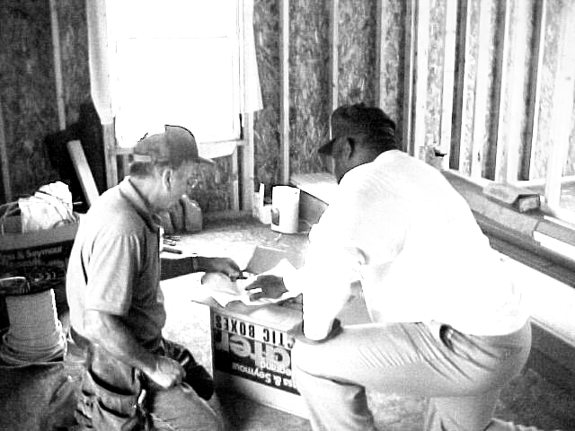

Volunteers getting ready to wire the Mennonite House

Work continues on the house on Scott Street sponsored by area Mennonite Churches. With the completion of drywall work the next step is painting each room. When that is completed it will be ready for finish work. If all goes well, a February dedication could be planned.
Meanwhile, across the street, another house is under construction. Financed by homeowner mortgage payments and a generous contribution from Sprint Telephone, ground breaking took place on October 25, immediately followed by excavation and foundation work. Today the house stands enclosed, enabling inside work during the cold winter months.
Carl Gauthier and Stan Bauman, construction managers, capably oversee the continuing work on both houses.
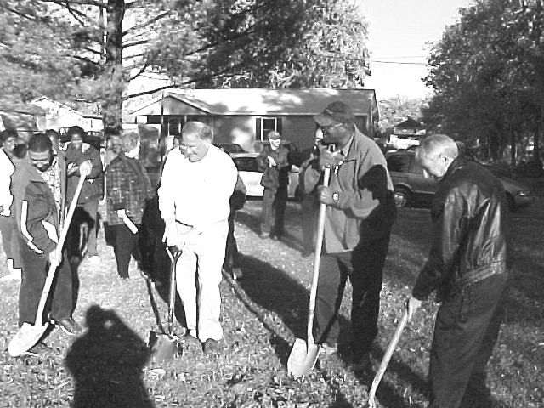

New homeowners, Rickie Evans, Sr. and Jr., and Claude Cliborne from Sprint break ground

