Gratitude

Karl Barth, the German theologian, once made the observation that all sin is simply ingratitude. This profound observation is worthy of our contemplation---also in the work of Habitat for Humanity.

All through the year we have been asking for your assistance in the work of Habitat. We had set a high goal---four new houses for the year 2002---so we did even more asking than usual. We asked you volunteers to give up your time to help build these houses. We asked prospective homeowners and their families to complete their hours of sweat equity. We asked area churches to sponsor individual houses, with financial and volunteer support. We have been tempted to take for granted the office space so generously given us at Market Street Presbyterian. We asked local businesses to contribute funds and materials for these houses. We asked individual contributors to provide funding to make four houses possible. We asked Club 1000 members to renew their memberships and encourage others to become members. We asked Committee and Board members to make Habitat meetings a priority to help us get our planning done. We asked staff members---in the office and on the work site---to generously share their time, even with very modest hourly wages. And the list could go on.

Now at the end of the year---in this Advent season when we once more experience Gods generous grace---it is time for us to share our gratitude and express our thanks! Gratitude in its biblical understanding conveys the notion of unmerited grace or favor, hence received in humility, and thus also in a spirit of self-giving rather than self-serving. It is in this spirit that we would like to share our appreciation and gratitude with all of you generous supporters of Habitat for Humanity in the greater Lima area.

And together we have much cause for gratitude. Two homeowner partner families have already moved into new homes. The third house is near completion, and the fourth house is enclosed for completion this winter!

Best wishes to you all for a joyous and blessed holiday season!

Elmer Neufeld, President
Habitat for Humanity---Lima Area

Habitat Welcomes New Partners

Once again, Habitat for Humanity—Lima Area, Inc. has been blessed with new partners to help us build. These partnerships are especially helpful when a house does not have a sponsoring organization, which is the case for our latest build on Reese Avenue. In addition to the regular faithful volunteers, Bluffton College Chapter Affiliate students, Apollo Heavy Equipment Classes, and the Lima Senior High School Carpentry Classes, we have also had the help of two more groups of helpful and enthusiastic workers.
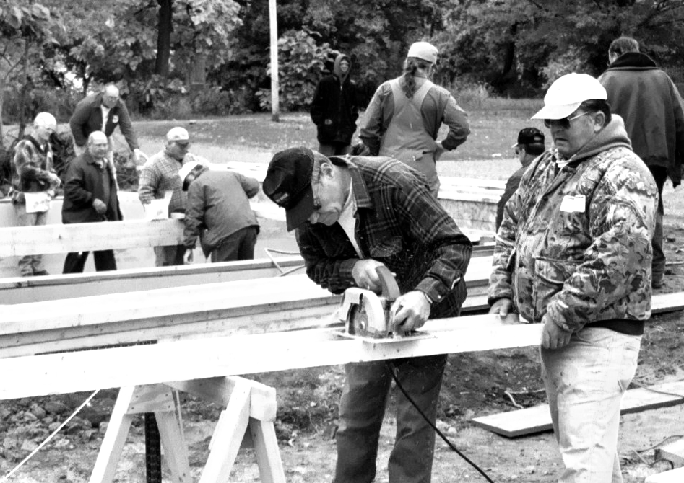

Ford Retirees at work on 1044 Reese floor

The first group to help us out in a pinch was the Ford Retirees. These community-minded men usually build wheel-chair ramps, but since they were caught up on that effort, they were available to put on the floor joists and sub-floor on 1044 Reese Avenue one Thursday in late October. A framing crew was then able to frame up the exterior walls the following Saturday.
The other new group to help us out is here temporarily. They are a National Guard unit from Iowa stationed here for security at the tank plant, helping out in the community in their spare time. We appreciate their willingness to assist us here in Lima.
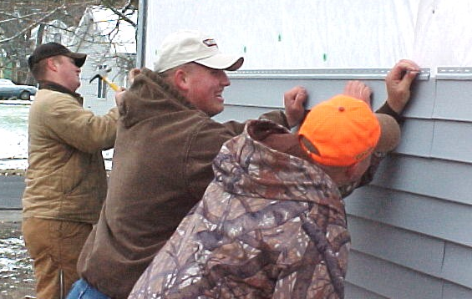

Iowa National Guard helping side 1044 Reese

Did you know….

Habitat for Humanity International has 2196 affiliates?
Habitat for Humanity has a presence in 83 countries?
The U. S. affiliates total 1651, 74 of them in Ohio?
Since its beginning in 1976, HfHI has built 130,000+ houses?
The average sale price in the U.S. is $48,537?
The average sale price overseas is $4000?
HfH is the 15th largest homebuilder in the U.S.?

Construction Committee Update

2002 has been a banner year for Habitat for Humanity- Lima Area building projects. To date, two houses have been built from start to finish, and two more are underway. Thanks to the efforts of many volunteers, one of those houses, sponsored by Lutheran Churches in the area, is nearing the finishing stage. The fourth house is also closed in and will provide work opportunities throughout the winter months. It has been great to see individuals, businesses and organizations once again joining together in this partnership to provide decent, affordable housing for Lima area residents.
Unfortunately, work on the two unfinished houses has been held back November and December. This is not because of a shortage of willing workers, but as the result of a lack of funds to purchase the needed building materials. Though a partial sponsor has appeared for the Reese Avenue house, our goal of building more homes each year means that we will also need an increase in donations to meet the up-front costs of building those houses. Our partner families have been working hard along with the other volunteers to make their dream of home ownership a reality. We don't want to let them down! Giving of your time and resources is one way you can make a positive contribution to our community, and improve the standard of living for everyone.
Thanks to everyone who has been involved with these building projects in the past year. And thank you in advance to all those who will continue to give support throughout the coming year. We can't do it without you!
Mel Hathaway, Construction Committee Chair

Site Selection Committee Has Big Job

The Site Selection Committee has been active in locating additional lots for future building sites. Due to the recent construction and plans for 2003, additional sites will be needed to maintain the goals of the organization.
One of the goals is to construct homes in close proximity to each other in order to develop a sense of community among the homeowners, as well as making a visible impact on the neighborhood. A drive down Reese Avenue provides an excellent example of this concept. We are always open to and appreciative of the donations of lots, although such donations must be considered in light of the size of the lot and availability of other lots nearby.
For building in 2003, we still have several lots on Scott and Union Streets. The Scott Street lots are around the corner from the Vine Street lots where the first two houses of 2002 are located, and the third house this year is the first in the Union Street location. For future building, we have lots on Summit Avenue, but the necessary infrastructure is not yet available there.
The committee will continue to explore possible building sites that meet our criteria and acquire them as funds are available.
Ed Van Horn, Site Committee Chair

New Millard Fuller Book Now Available

Habitat for Humanity Founder
Miller Fuller has recently released
another book, this one quite unlike
any of his many others. Building
Materials for Life is a collection of
40 inspirational essays, focusing on
spiritual gifts or lessons. The writings
make wonderful devotional readings.
The book may be ordered by
calling (800) 422-5914 or may be
picked up at our office in Lima. The
cost is $10. Other Fuller books avail-
able in our office are More Than
Houses, Theology of the Hammer, and The Excitement is Building. Call us at 419-222-4937 for more information.

Nurture Committee Sets Goals

The Family Nurture Committee met several times during 2002 in partner family homes. Long-time homeowners are invited to become acquainted with new homeowners and also to get involved with their neighborhood associations.
Serving on the committee and attending the meetings are four volunteers—Don Hauserman, Dick Hansgen, Mitch Kingsley, and Ellen Ditto. At the November meeting, homeowners were encouraged to consider attending the 2003 Habitat Regional Conference in addition to workshops to enhance their knowledge of homeownership.
Goals set for the new year are 1) to encourage and assist homeowners in becoming independent and self-sufficent homeowners, 2) to assist new homeowners in the transition from renting to ownership, 3) to welcome new partner families to the Habitat community, and 4) to assist all with mutual support and educational opportunities.
Marilyn Taylor, Nurture Committee Chair

Club 1000

We still seek persons or groups in the Lima Habitat Area who would be interested in joining Club 1000. Our dream of1000 individuals/groups pledging to support Habitat for $10.00 per month is still far short of its goal. 1000 members would generate enough money to build up to five houses each year, our other vision. Are you being called to join Club 1000? If so, please call the Habitat office for more information (419-222-4937) or mail in your pledge or gift.
