Family of Faith Dedications Held
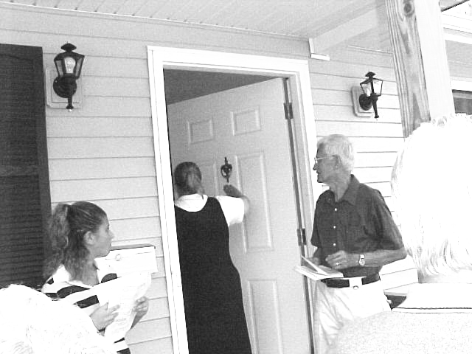

New homeowner Barb Fisher blesses her entrance as daughter Brittany and board president Neufeld watch.

On September 14, exactly four months after the groundbreaking ceremonies for the Family of Faith project kicked off activity on the project, another milestone was reached in the lives of new homeowners Barb Fisher and Vodria Ellis. The two new houses, located at 712 and 714 E. Vine Street, were dedicated in a ceremony attended by approximately 50 participants and onlookers.
Held not only as an event to commemorate the completion of the homes but also to celebrate Building On Faith Week with all affiliates around the world, the program recognized volunteers, providers of skilled services, donors, and local and national business partners. In a special blessing ritual, various components of the homes were anointed with water after prayer from those gathered for the event. Following the ceremony, all were invited to tour both houses and stay for refreshments and lunch, provided by the homeowners.
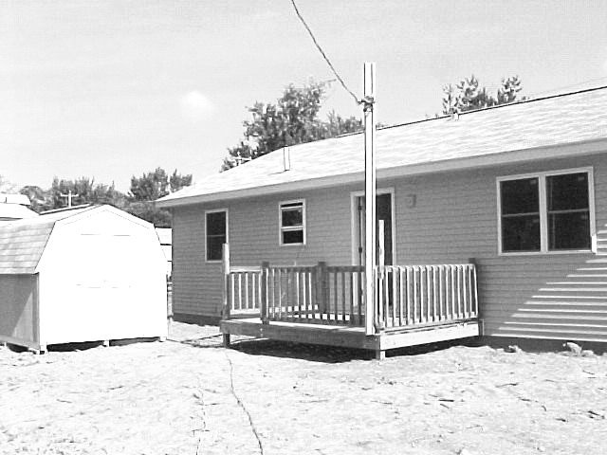

Rear of 712 E. Vine (above) and front of 714 (below)
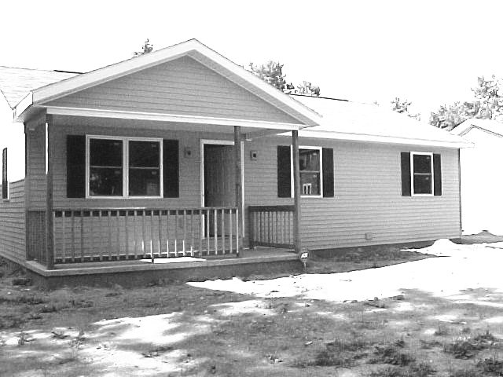

Habitat Welcomes New Partners
Habitat Welcomes New Partners
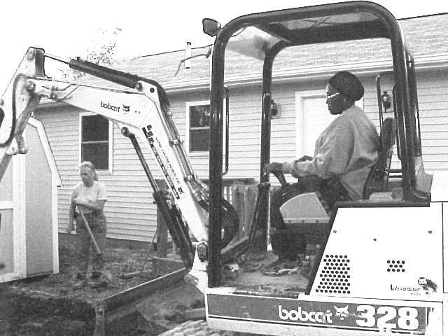

Apollo student Jannie James moving earth

Lima’s Habitat for Humanity has formed two new partnerships in our construction efforts. The Lima Senior High Carpentry classes, with their instructor Terry Hedges, has been assisting with the Lutheran House and will work with us throughout the school year. Also joining us is Apollo’s evening Heavy Equipment class, who are in session for the months of September and October. They have been helping us on our Vine Street site as well as on Union Street, and we hope to have our fourth house underway early enough to take advantage of their developing skills in earthmoving.
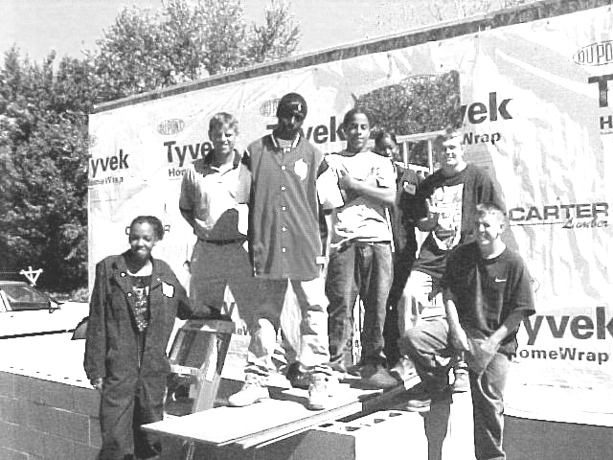

Lima Senior High P.M. Carpentry Class

Thank You
Words can’t express the way I feel about all of the many volunteers, family, friends, committee members, foremen & planners, suppliers, electricians, plumbers, and food providers. From start to finish, as one of the homeowners on East Vine Street, I thank you all.
Without the grace of God and faith, love, charity, and patience of all of you, none of this would be possible. You will always be in my prayers and thoughts.
God bless and keep you.
Vodria Ellis
2001 Tithes Build Houses in Africa

All Habitat for Humanity affiliates in America are asked to tithe to support the efforts of the international organization. Lima’s contribution from its 2001 income went to assist with building efforts in Africa, with $4000 to go to each of three countries on there. We have received word from Zambia that our contribution to them will go a long way toward the purchase of materials for three new homes. These are simple three-room structures made from concrete blocks and roofed with galvanized iron
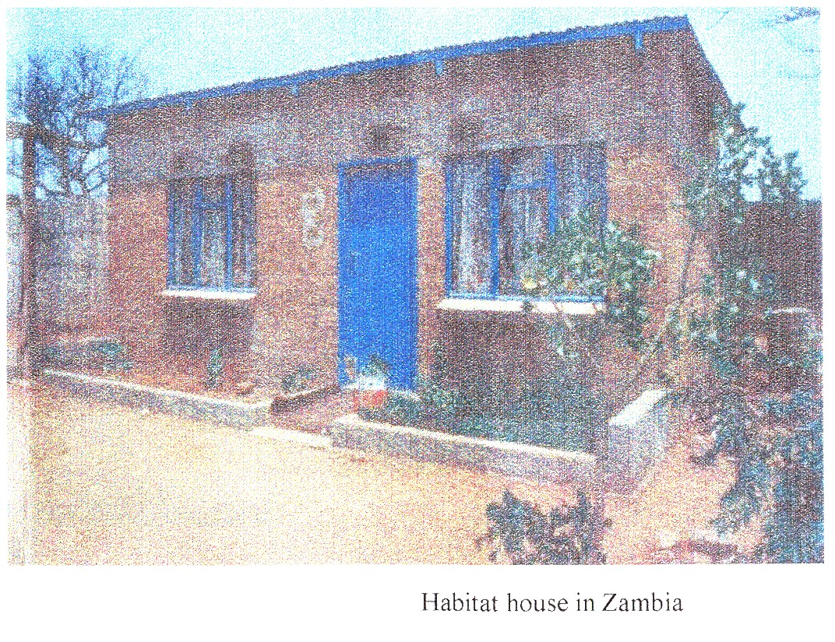
sheeting. A ventilated pit latrine
is also constructed. The home-
owner family prepares the blocks
and digs a foundation prior to
building. Habitat for Humanity
Zambia plans a large project for
Lutheran House in Progress

Ten area Lutheran churches have combined to sponsor the third Lima Habitat house, currently under construction at 1031 S. Union Street. That home will belong to Anna Jones and her family. The churches have been planning for several months, and got started with their first workday on September 7, with the foundation already in place. Construction should be finished near the end of the year.
The ten churches involved are New Creation, St. Luke’s, and Zion Evangelical Lutheran Churches of America in Lima, Evangelical Lutheran and St. Mark’s ELCA in Wapakoneta, First Evangelical Lutheran in Bluffton, St. Matthew’s ELCA in Cridersville, Trinity ELCA in Moulton, St. Paul’s ELCA in Botkins and Zion ELCA from Lafayette,
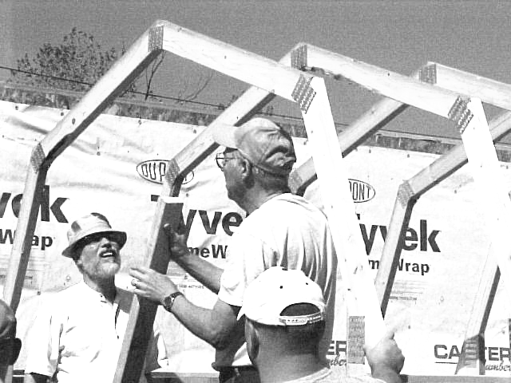
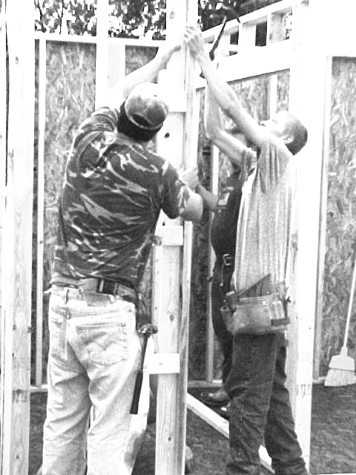

the spring of 2003.

Update from Church Relations

The Church Relations Committee continues to work towards better communications with the area church families. One of the ways that will help with that is to have a representative from various denominations and congregations to join the committee. Are you possibly one of those persons who would like to work with the committee to enhance communications with your congregation, keeping them updated on the Habitat for Humanity of Lima Story?
Presently the committee is preparing a notebook for churches to use in sponsoring a house project. We feel that with this “how to” notebook, any congregation would be able to adopt the steps in the book and be prepared to sponsor a house by themselves or with the assistance of other congregations.
We also are seeking persons or groups in the lima Habitat Area that would be interested in joining Club 1000. Our dream is that 1000 individuals/groups would pledge to support Habitat for $10.00 per month. This would generate enough money to build as many as five houses each year, our other vision. Are you being called to join Club 1000? If so, please call the Habitat office for more information. (419-222-4937)

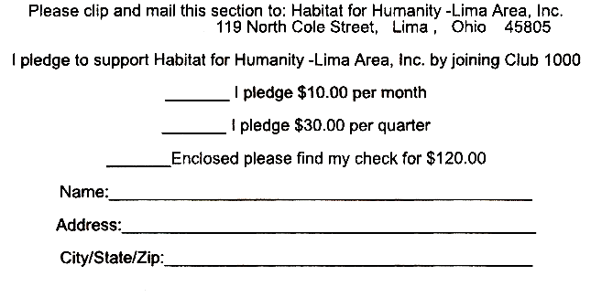

Work in progress, September 21, 2002

Volunteer Committee News

On Tuesday, September 17, this committee met to discuss How do we change to meet the needs of an ever-increasing building program? At present we are doing this with only two committee members, who are only able to call and locate volunteers for Saturday workdays. However, that’s just not good enough for our plans to build 5 homes next year. We need to be able to find and recruit new volunteers of all kinds.
We have about 165 people on our volunteer database. That’s a lot of people, but 50-75% of the skilled volunteers are not available to help us on a given Saturday. This problem is compounded by the fact that every couple of years, many of our more skilled volunteers drop off our database. They may have moved away, have family commitments, feel they are too old or unwell to keep helping, or feel that God is leading them to a different ministry. A smaller database means fewer workers. We need your help so that we can network with area businesses, area churches and local labor unions to find the skilled and somewhat skilled workers that we need to continue our interdenominational Christian building program.
In addition, there are many area groups and schools who want to help Habitat as it builds simple decent homes with families in need. Our committee is too small to be able to work with both groups and our regular volunteers. So, our staff people must work with them in addition to their regular jobs.
We need you!!!!! If you like working with people, call Don McClure at 419-331-6027, and we’ll put you to work.

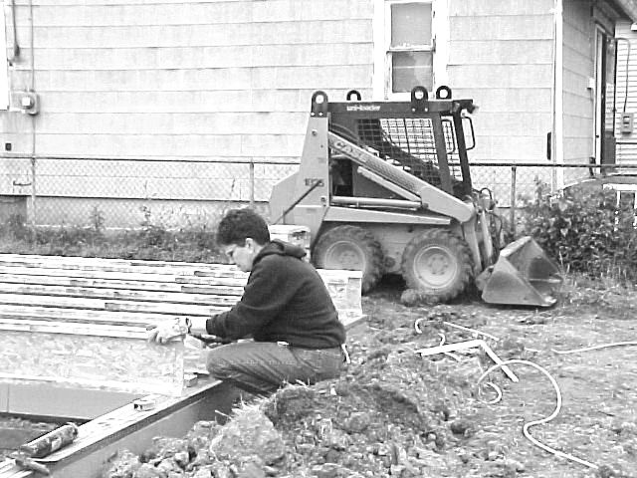
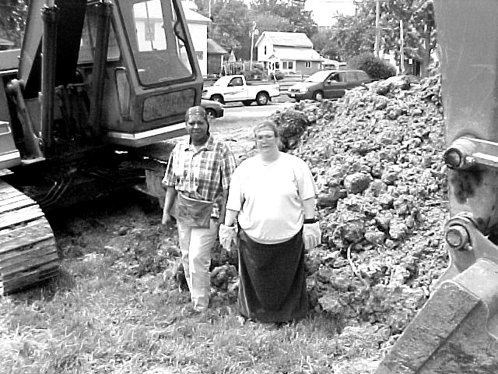

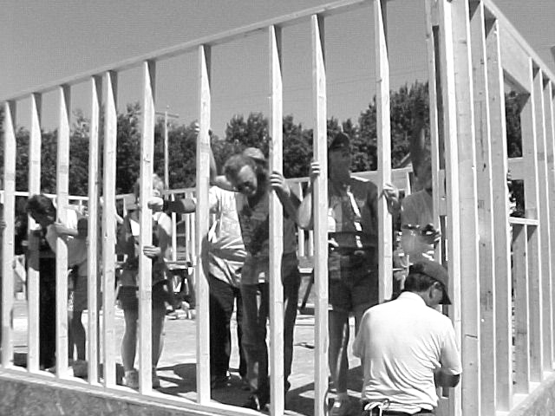
Family of Faith Project
in progress
