Family Selection Team News

The Family Selection Team is currently working with four Lima area families. We hope to have two of these to present to the Board of Directors at its April meeting. One of the families, if approved, will allow us to build our first home outside the city limits of Lima.
Our most recent Family Selection Drive was held on March 16 and 18, with the next one scheduled for June 15 and 17. We continue to work with previous families as we search for new candidates.
We have also been working on a new pamphlet which can be mailed to callers interested in a Habitat home. The pamphlet is our revision of one developed by another Habitat affiliate. It’s designed to be a simple, step-by-step guide to show potential applicants if they are indeed qualified. Many thanks to Ralph Stelzer for formatting and adding clip art to the pamphlet for us.
If you have a heart for compassionate ministries, join us as we work to find families in need of simple, decent homes. Call Chair Don McClure at 331-6027 to volunteer to serve on this committee with him, Laura Duckworth, Diane Jones, and Barb Stelzer.

Site Development Committee Hard at Work

The Site Development Committee, consisting of Chair Bruce Hilty, Mike Dix, and Ed Van Horn, is proving that even a small group can be mighty. They have acquired almost all of the land on Reese Avenue to complete our Habitat neighborhood there. We now have an additional three sites there to add to the four houses we currently have in place on that block. Since that area now is nearly all Habitat’s, the committee is lining up a new neighborhood, hoping to acquire a number of lots in another Lima area.

Nurture Committee Building Homeowners

The Family Nurture Committee has the rewarding job of working with the Habitat homeowners as Habitat goes about its goal of building community as well as homes. The committee is to maintain and improve relationships with the present and future families and volunteers. In addition to giving each selected applicant a Nurturer, this group meets monthly in the homes of the homeowners and committee members with the aim of encouraging the homeowners to become responsible and successful at maintaining and beautifying their homes.
In addition to sharing personal ownership issues, attendees are treated to speakers who provide programs of general interest and benefit. A few of the speakers and their topics are these: Merilee Ziccardi—“Maintaining Lawn Care,” Attorney Mitch Kingsley—“Legal Issues for Homeowners and How to Make a Will,” and Ken Pulley—“Lima Habitat Policies: Mortgage Payments and Responsibilities of Homeowners.
Each new homeowner is encouraged to attend the Lima Homeownership classes with Larry Goodman at LACCA. Some of our early owners, who did not get in on these classes, are now interested in attending them. Thanks to this committee for their nurturing work. Members are Chairperson Marilyn Taylor, Janelle Augustus, Don Hauserman, Vickie Shurelds, and Bonnie Stiles. Anyone interested in volunteering to participate in their work, call the Habitat office at 222-4937.
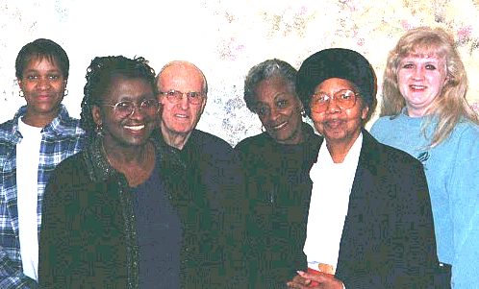

Nurture Committee and Homeowners

Church Relations Committee Active

Another committee hard at work, the Church Relations has been planning and carrying out several activities of their own. The committee planned and held a special breakfast meeting on March 18. Invitations were sent out to approximately 100 Methodist lay persons in Allen and Auglaize Counties to become actively involved with Habitat. The breakfast was held at the Old Barn Out Back, with several churches indicating interest.
Another event being planned by this group is the Spring Rally, which will be held at Holy Tabernacle Church at 3:00 p.m. on Sunday, April 30, 2000 (See back of newsletter). Special music and speaker will be part of the agenda for the day.
Leroy Troyer, architect and former member of the Habitat for Humanity International Board of Directors will be talking to us about thriving affiliates, the world wide dimensions of Habitat for Humanity, and his experiences with the Jimmy Carter projects.
Carol Blass, Chair, and Lavon Welty welcome Roger Miller to this committee and invite interested others to call the Habitat office at 222-4937.

Club 1000 Memberships Open

Club 1000 is a fund-raising program of Habitat for Humanity—Lima Area, Inc. The Club 1000 members pledge just $10.00 per month throughout the year to support Habitat’s ministry in Lima. With a membership
of 1000 strong (our goal), each contributing $120 per year, at least three new houses can be built each year. For only $10 each month, you can help ensure that three more families each year can have the basic housing that we all take for granted. Join today! Become a participant in our growing ministry! Help us build three more houses in 2000. Contributions are tax deductible and greatly appreciated.

Annual Meeting

The Annual Meeting of Habitat-Lima was held at Trinity United Methodist Church on March 14 and was attended by 40-50 Supporters, Volunteers, and Homeowners. After a brief introduction and welcome by Board President Elmer Neufeld, Trinity Pastor Bill Croy provided a very inspirational message in the opening devotions. This meeting which was open to the public provided: a review of our progress; our plans and dreams to build three houses in 2000; and an opportunity to meet our Homeowner Families and meet and recognize our dedicated Volunteers.
Over 170 Volunteers and Suppliers were recognized for their support with Certificates of Recognition. Six individuals and/or organizations—Trinity United Methodist Church, Carl Helmig, Les Ingmire, Bill Snider, Dave Smith of IBEW, and Bob Torbet of Rent All Mart—were recognized with special plaques for their extra service and ongoing commitment to Habitat. Les Ingmire and Bill Snider have led the effort this past Winter to finish the Geneva Williams house at 1037 Reese; and with that effort, we hope to move Geneva and her Family into the home before Easter. What a glorious way to celebrate the Resurrection of our Lord!

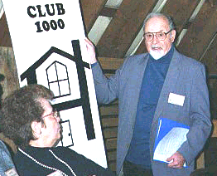

Church Advocate Claude Boyer presents Club 1000 as Church Relations Chair Carol Blass looks on

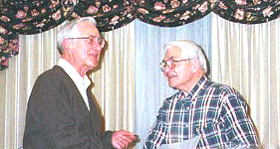

Ken Pulley presents certificate to Royce Engle

Habitat Responds to Break-ins

After experiencing our fourth break-in in five months, Executive Director Ken Pulley addressed a Lima City Council meeting to express his concern over these events, but more importantly, to urge the City government, the police, the community, and the neighborhood associations to work together and to work harder to provide the safety and security that all neighborhoods deserve. With seven Habitat houses in the Reese Avenue and Second Street area (and more to be built), this is truly a “Habitat Neighborhood.” We are outraged at the violation of the commitment we have to provide Families in Need with a simple, decent home in a safe and secure neighborhood

