(Continued from page 1)

How can you get started? You can see that Habitat offers many wonderful opportunities to make a difference in our community. Here are some steps you can take to get started: Take one step at a time:
Step 1: Give thoughtful consideration and prayer to your own level of participation for 2002. Contact the Habitat office if you need further information. By the end of January be clear in your mind how you want to be involved in 2002. Call the Habitat office–419-222-4937 and request a volunteer form to let us know how you want to be involved for 2002. We will be glad to talk with you further about your particular interests.
Step 2: Find out who else in your congregation or community or civic club is already involved. If there are others already involved with Habitat, get on board with them. Form a task force to determine the level of commitment. Contact the Habitat office to find out the requirement for people, time, and money or other form of material support and how much of that you can offer. Then, by the end of February 2002, let us know what you want to do.
Step 3: During the months of March and April, join with Habitat in the planning process. Form prayer teams, building teams, food preparation groups, and find a Habitat advocate, according to your level of commitment. Determine how to raise the funding, whether it be by mission funds already available, fundraisers such as dinners, special drives, auctions, etc, or by getting enough members for Club 1000 to reach your goal.
Working in Lima makes a difference in some overseas location! So you really wanted to help in some far off country? Our local Habitat Chapter happily tithes (gives 10%) of all local donations to Habitat for Humanity International for work in many different parts of the world. For each home built in the U.S., a tithe is enough (on average) to provide a house in a foreign country. Lima's affiliate does observe the tithe. We like to think that there are eleven houses somewhere out of the U.S. paid for by our tithe from your donations, with two more to come from this year's building.
You wanted to respond to the events of Sept. 11. Jimmy Carter said it for us in his remarks on Sept. 16 at our meeting in Indianapolis: "Habitat not only provides hope and a realization of faith to an individual family, but also provides a means by which we can expand our religious faith to encompass others and to draw us nearer to God. It's not just governments that have the responsibility to resolve crises. It's really a conglomerate of dedicated individuals, and this is particularly true in democracy to demonstrate our faith -- our faith in ourselves, our faith in each other and our faith in God. This is what Habitat means to me."
Building a house for Habitat is a service opportunity with many benefits for the participants. It is not only a chance to give of yourself, but also to rub elbows with other volunteers, the family and friends of the homeowners, and students from area campus chapters of Habitat. You might pick up some construction tips from experienced builders. Even though it doesn't beat the fellowship, the food is pretty good too.
Mennonite House Dedicated

Part of Habitat’s mission is to build neighborhood and community, which we have done on Reese Avenue and will continue to do in Lima. Half of the 600 block of Fairview Avenue used to consist of overgrown, untended property with impassible sidewalks, but now it is graced by two brand new houses complete with new walks and some landscaping.. With the dedication of the Mennonite-built house at 698 Fairview, the project there is completely finished.
A home for Emilie Hamman and daughters Katie and Rosie was dedicated on Saturday, December 15, in the presence of approximately 40 volunteers and donors, with contingents from the churches involved in its construction. Representatives from the Board, the City, and the Mennonite spoke, and the home received a blessing from those present led by Dorothy Nickel Friesen, pastor at First Mennonite Church in Bluffton.
The house was funded and built by area churches including First Mennonite, Lima Mennonite (Bluffton), Pike and Salem Mennonite Churches (Elida) and Grace and St. John Mennonite Churches (Pandora). The project was led by Habitat Construction Chairman Mel Hathaway, pastor at Salem, and Mark Hollinger and Stan Bauman, Construction Managers for Habitat.
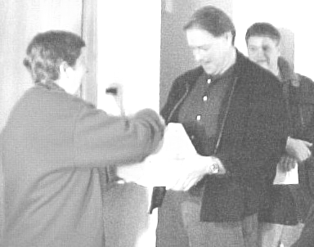

Emilie Hamman accepts tools for home maintenance from Mark Hollinger, Summer Construction Manager

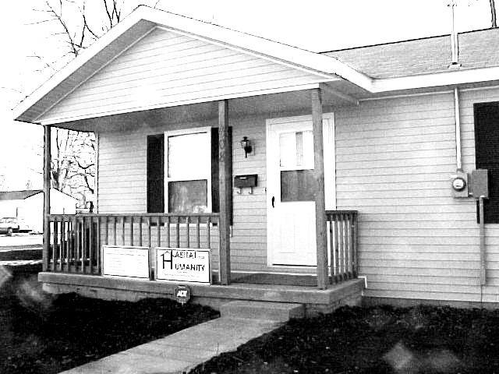

The Hammans’ house at 608 Fairview.

Club 1000
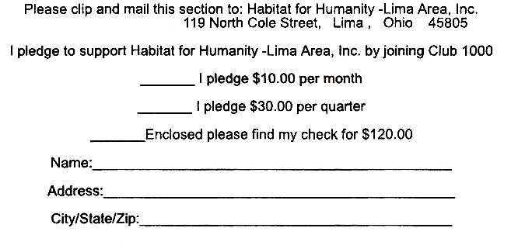

We are still a long way from our vision
of 1000 members each giving $10 a month.
Please join us in making dreams come true.
A membership in Club 1000 is a terrific way
to start a new year. Don’t forget that your gift
is tax-deductible.
Won’t you help us in our mission to
build more simple, decent, affordable homes for
families in need? We have built thirteen now
and would like to put up many more. Only $10 a
month will help a deserving family obtain a home.

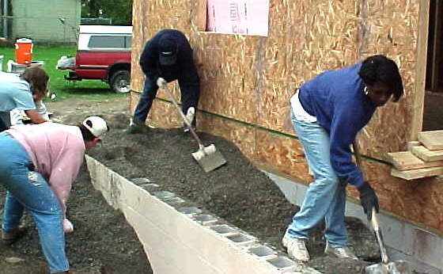

Ken Pulley House Nears Completion

We have come a long way since September 15 marked the first volunteer day for the Ken Pulley Memorial House. The house is complete on the outside and looking good. On the inside, it is in the drywall finishing stage. Painting and finish work remain to be done before our homeowner, Donna Ingram, and her family can move in. Many volunteers have helped bring the house to this stage. Building volunteers have included many who had worked with Ken Pulley during his years as Executive Director. In addition to individual volunteers too numerous to list were groups from area churches that included Lutherans, Methodists, Catholics, Mennonites, plus individuals from various other denominations, making an ecumenical mixture that served together very well. Ken would have been very pleased.
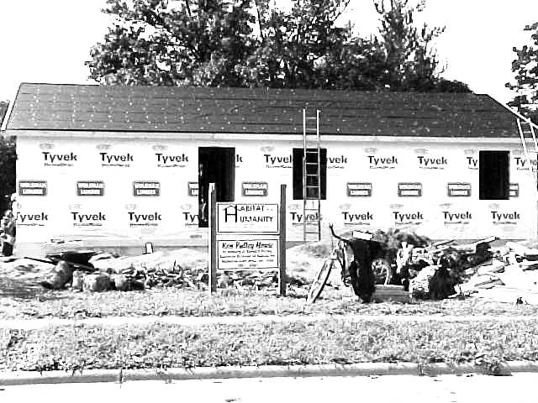
Homeowner Donna Ingram and volunteers at work on the porch,…
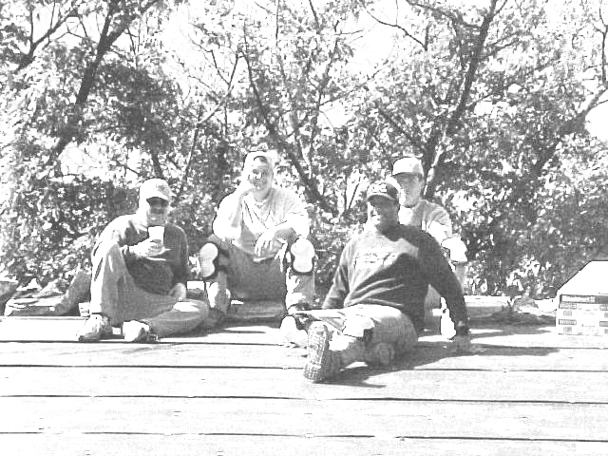

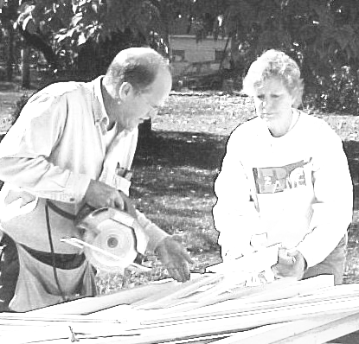

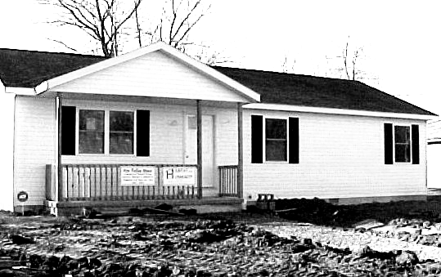
Pulley House, 1040 Reese Avenue—Sept. 28, 2001
Pulley House—Dec. 11, 2001
…on the roof…
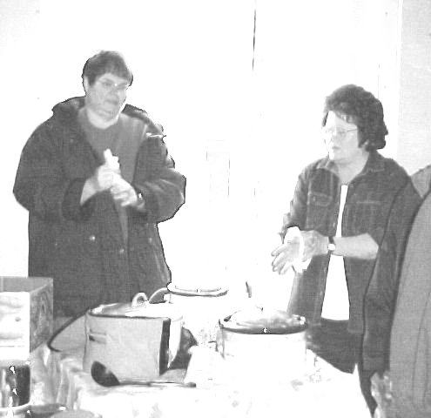
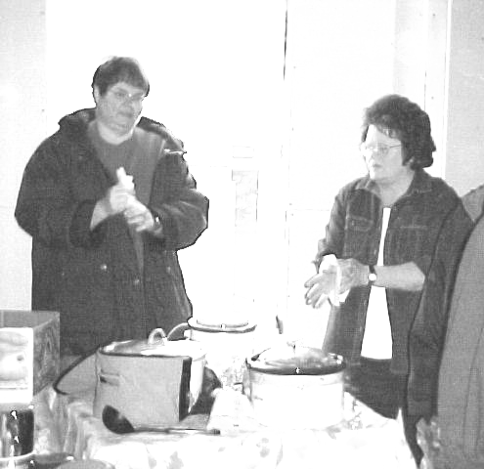
…serving lunch…
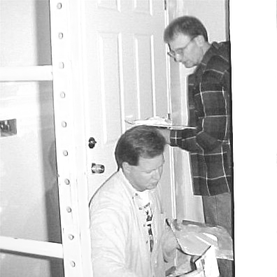
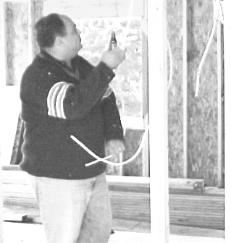
…finishing drywall
…cutting siding…
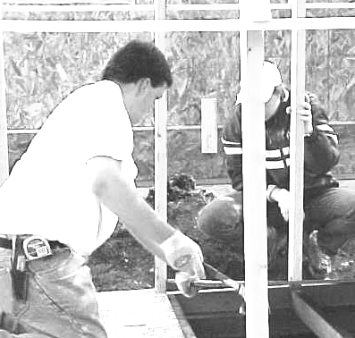
…framing…
…wiring…

