Family of Faith Project in Full Swing
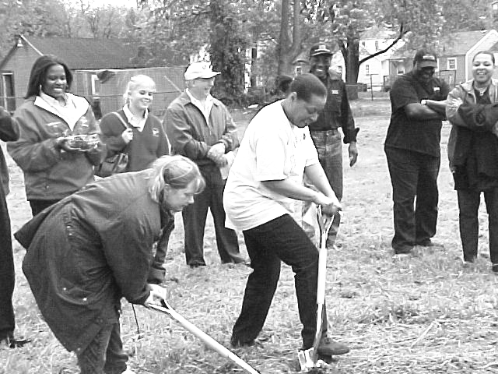

New homeowners Barb Fisher and Vodria Ellis break ground for their new homes.

On May 14, a groundbreaking (somewhat delayed by the rains) kicked off the new building season for Lima’s Habitat. The Family of Faith, an ecumenical initiative, got off to a symbolic start. Sister Teresita from Lima Central Catholic High School planned a ceremony that included members of the families who will live in the two new houses, members of the clergy, students at LCC, and others who will be involved in the build.
Since that time, the two houses, located at the corner of Scott and Vine Streets, have come a long way. Large numbers of volunteers have been reporting for duty every Saturday, and smaller groups have come on some weekdays. Those early shovels full of dirt have become fully framed houses ready to side and drywall. Before winter, Barbara Fisher and her daughter Brittany will occupy 712 E. Vine Street right next door to Vodria Ellis at 714.
Partnerships a Help to Building Efforts

Both local and national partnerships give an enormous boost to local efforts. Over the years, we have been blessed by Lima area businesses and U.S. corporate sponsorships, donating either goods or services, and sometimes both. Just a few of our local partners

Ford Motor Co. (Volunteers)
Helmig
Otis Wright Trucking (trailer for storage)

Volunteers Recognized at Annual Meeting

In addition to helping build the Ken Pulley house, our Bluffton College Habitat for Humanity Chapter has been busy with activities of its own. In early March, eight chapter members and two adults worked with Green County Habitat for Humanity in Waynesburg, PA, for their Spring Break trip. They assembled interior and exterior walls for over three houses that will be built this spring and summer.
Besides building activities, the students have also been raising funds and awareness. They have had a bake sale, a bowl-a-thon, and an aluminum can collection to raise money, and on April 6 will hold their annual Pancake Breakfast at First Mennonite Church in Bluffton from 7-11 a.m. (Everybody welcome!)

Habitat Welcomes the WORTH Center
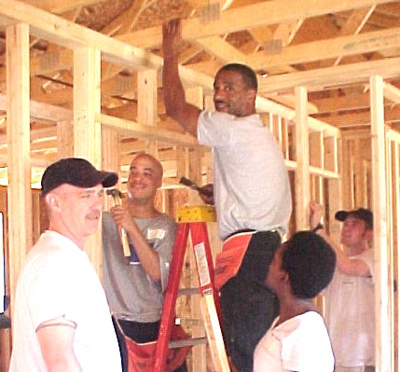

Lima’s Habitat has formed a new partnership in the area, one where residents at the W.O.R.T.H. Center are assisting with the building of Habitat houses. Crews of four to six have been coming to work on most Tuesdays and Thursdays. With their help, the houses can be prepared for the usual big Saturday workday. These new volunteers are excited about the opportunity to help others and give to the community, so much so that several have asked if they can continue to serve with Habitat after they have finished their sentences.

Volunteer Committee Hard at Work

Have you ever watched a circus juggler do his thing? He starts with one object and keeps adding others until the air is filled with flying objects. Somehow, he manages to keep them all in the air without them bumping into each other or being dropped.
Calling volunteers for Habitat’s workdays is another type of juggling act. You need the right mixture of skilled volunteers to lead the workday; you need people with more general skills to help, and you need to rotate through the list of volunteers so that all are called and given a chance to help on a regular basis. The job is complicated by vacation plans, job schedules, injuries, people moving and not leaving a new phone number, and a constant string of new volunteers to add to the database. We need to try and schedule not only individuals but also groups. During the construction season, it seems like the only thing we get done is contacting volunteers.
During the quieter times, we work with the local building trades council, the local unions, and local churches to try and fill in areas where we need more people with specific skills. If you like challenges and enjoy working with people, this committee is for you. Contact Don McClure at 331-6027 and see how you can get involved today!

