Jimmy Carter Work Project 2003

This year’s Jimmy Carter Work Project will take place in three communities that have set dates for eliminating substandard housing. They are Anniston, Alabama, and LaGrange and Valdosta, Georgia. Former President Jimmy Carter, 2002 Nobel Laureate and Habitat’s most famous volunteer, will spend time during the week of June 8-14 in all three cities to help build and to call attention to this very ambitious effort. For information on how to be a part of the Jimmy Carter Work Project, visit the web site at www.habitat.org or contact Rita Clemens in Americus at 800-422-4828 or at rclemens@hfhi.org. More information is available on the web site along with downloadable registration forms.

Housing Efforts in Lima

Habitat for Humanity is no longer the only game in town for low-income families who are willing to live in the south end of Lima. Two new organizations have gained the permission of City Council to build in 2003. One is called New Lima, a non-profit builder who will be selling homes at cost to low-to-moderate income families. They will prepare foundations for quality pre-built homes and do the rest of the work needed to get the houses ready for occupation. The differences between them and Habitat for Humanity are that they use a conventional mortgage with interest (through a bank), unlike HfH’s interest-free mortgages; they will hire the workers rather than using volunteers; and they take applicants with higher incomes than HfH. This organization is working with us to choose sites which will improve neighborhoods between Vine and Fourth Streets.
The other builder soon to make its presence known is Miller-Valentine Homes. They are a for-profit company that builds mostly multi-family units for low-income, but has recently expanded into the single-family unit business. For a low-income family, they provide a new pre-built home which includes an attached garage and concrete drive. The house must be leased for fifteen years, at the end of which time the homeowner will secure a conventional mortgage and buy it for cost, around $67,000. Buyers are provided with a down payment of $1000 a year for each year they have leased. While they are leasing, they may make improvements to the property if they secure permission from Miller-Valentine. M-V’s somewhat brief experience is that turnover in these homes is very low. Their plan is to build between Fourth and Eighth Streets, starting with a large, multi-house project on one site, with the rest being constructed on scattered sites as available in that area.
Homeowner payments in both of these initiatives will be approximately double what Habitat families typically pay, because of our interest-free factor. Volunteers also help us keep our costs down, so that our homes, similar in size and features (other than the garages and driveways), cost much less and give the homeowner a high-quality product. Although we prefer our way of doing things, we do need all of these organizations if we are ever to eliminate poverty housing in Lima and Allen County.
Volunteer Committee at Work

The members of the Volunteer Committee would like to thank all the volunteers who helped us make last year such a success. Because of your generosity, two more families have been moved from substandard living conditions into simple decent homes, and two more will be shortly. We couldn’t have done it without your help. 2003 promises to be another exciting year and we will need your help again.
Over winter, members of the Volunteer Committee have been calling all the volunteers on our database to check their availability for the upcoming construction season. We have also been brainstorming to see how to improve our operations and to give more people an opportunity to help us.
Our brainstorming sessions identified a need for more volunteers with electrical, plumbing, carpentry, and drywall skills. To try finding the needed help, we have contacted union halls and the Building Trades Council. With our expanding program, we can now offer the unions a place for apprentice classes to get needed experience as well as giving union members a place to showcase their skills.
If you would like to volunteer or help us on the Volunteer Committee, call Don McClure at 419-331-6027.

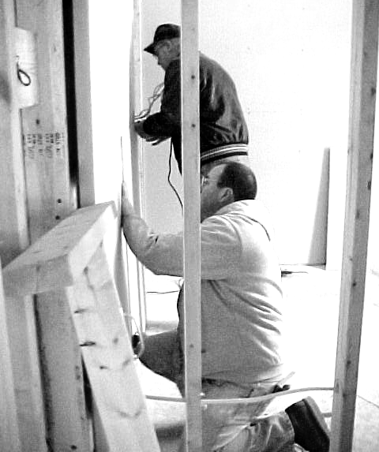
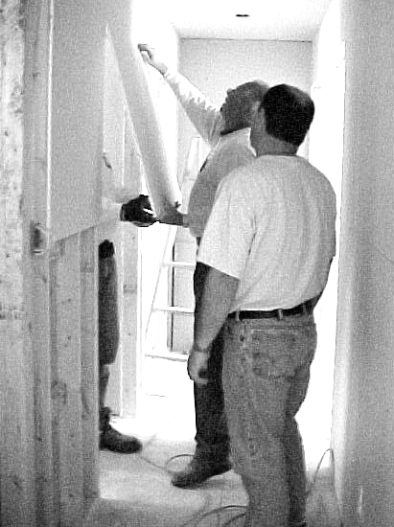

Volunteers install drywall at 1044 Reese Avenue

Church Relations Committee

The Church Relations Committee continues to work on a “tool kit” or notebook to assist churches and/or organizations in getting prepared to sponsor a build. We are happy to report that this document will be ready this spring and hopefully will be of help to both new and experienced sponsors.
We are blessed on the committee to have the Catholic, Lutheran, Methodist and Mennonite churches represented. However, we are always looking for other denominations and independent churches to send a representative. Members of the Church Relations Committee are so valuable in communicating back to their congregations and denominations the Habitat Story. Are you the person we are looking for? Would you like to assist us in communicating to groups the Habitat Story? Won’t you call the Habitat Office and volunteer to become a part of our committee? You will be committing to approximately fifteen to twenty hours a year. We look forward to hearing from you!

Club 1000

We still seek persons or groups in the Lima Habitat Area who would be interested in joining Club 1000. Our dream of 1000 individuals/groups pledging to support Habitat for $10.00 per month is still far short of its goal. We have increased our membership, but we have not yet reached to point where we could build a house from these contributions alone. 1000 members would generate enough money to build up to four houses each year. Are you being called to join Club 1000? If so, please call the Habitat office for more information (419-222-4937) or mail in your pledge or gift.

Thank You for Those Who Contributed in 2002

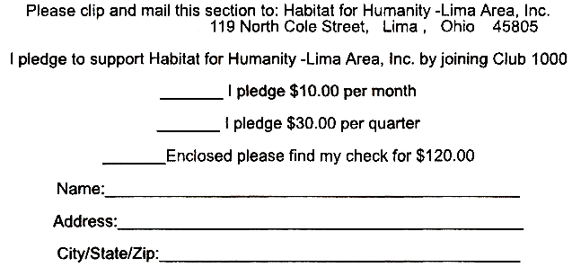

Floyd & Madeline Adams
Adult SS—Westminister CC
Conrad Aebker
Don Ammon
Fred & Mary Amstutz
Paul & Kay Assenheimer
Ed & Joan Baden
William Bassett
Sam & Barbara Bassitt
John & Sharon Bateman
Joan Bauman
T.R. Bauman
Stan & Suzann Bauman
Susan & Gerald Biesecker-Mast
Jack Bilen
Karl & Carol Blass
Mabel Bowers
Claude & Mary Boyer
Andy & Ada Brenneman
Brice & Lydia Brenneman
Don & Elaine Brubaker
Jon & Lisa Carver
CD Class of St. Paul UMC
Jane & Joe Churchman
Stan & Joenita Clemens
Henry Councilman
Diana Diefenbacher
Vince & Laura Duckworth
Ellen & Royce Engle
Bob & Sue Fett
Perry & Gerry Fox
Virginia Franks
Richard & Dorothy Friesen
Grace Frounfelker
Tom & Geraldine Frueh
John & Annette Gaeth
Gil Net Class-Westside UMC
Al & Jane Good
Genevieve Graham
Paul & Joy Gruetter
Ron & Judy Hagaman
Julia & Dick Hagen
Ruth Haman
J. Irene Hamman
Mike/Ellen Hanafee
Bill & Lavonne Hartman
Ruth Hartzler
Mel & Dottie Hathaway
Don Houserman
Grace Heaston
Howard & Nola Heilman
Glennys Henry
John & Joan Hill
Marjorie Hollinger
Jerry & Carolyn Huffman
James Hunt
Charles F. Irvin
William & Willadeen Keeney
Phillip & Judith Kingsley
Wilmer & Glenna Kirkendall
Koinonia Class—SPUMC
J. Grace Kozak
Elaine Krietemeyer
John & Joan Lee
Leland & Dorothy Lehman
Car & Sandra Liechty
Pauline Light
Kathryn Luginbill
Tim & Phyliss Macke
Hope Mathwig
Joyce McConnell
Pat & Dave McCormick
Richard & Mildred Meffley
Matt Meyer
John & Mary Ann Moser
Robert & Ann Muhler
Stan & Ruth Naylor
Darryl & Lorraine Nester
L. Lamar & Deborah Nisly
Dean & Joan Niswander
Tony Okuley
Wanda Pannabecker
Devin & Debra Parker
Donald & Carol Piehl
Joan Pulley
John & Christine Purves
Jim & Pam Raabe
Wm. Todd Rainey
Robert & Alice Ramseyer
Anne Reichenbach
Tonya Ridenour
David & Margaret Rumisel
Evelyn Runyan
Lester & Helen Shenk
Luther & Geneva Shetler
Robert Sielschott
Phyllis Simcox
Michael & Charlene Smith
Willis & Betty Sommer, Jr.
Ron & Sue Spencer
Jon & Brenda Stocker
Russel & Jean Suter
Phyllis Suter
Irene Swartz
Chuck & Imogene Swartz
Earl & Marilyn Taylor
Bob & Jean Tomlinson
Trinity UMC Women
Betty Troyer
Ed Van Horn
Mr. & Mrs. Dale Vondrell
Judith Waller
Deborah Walters
J. Richard & Margaret Weaver
James & Shirley Weinman
Lavon & Carol Welty
Women’s Fellowship of Westminster CC
Art & Carolyn Wilde
David & Susan Wilson
Francis Wisener
Robert Wolfe
DaVilla Workman
Arnita Yoder
John David Yoder & Lynda Nyce
Mary Elizabeth Zurfluh

Our apologies to anyone we missed inadvertently or who gave to Club 1000 through their churches, which may not have supplied us with their names.

Help Us Celebrate at Our Annual Public Meeting

Mark April 22 on your calendars as the date to attend the Habitat for Humanity—Lima Area, Inc. Annual Public Meeting. To be held in the Market Street Presbyterian Church, the meeting will run from 7:00 until 8:30 p.m. During this event, we will review the 2002 Habitat year; thank our sponsors, the many volunteers who helped, the donors, the businesses and organizations that made it all possible; and discuss our plans for 2002. We will celebrate it all with music and refreshments.
We invite everybody to come and be a part of our celebration of what has been accomplished and what can happen in the new building season.

A big, heartfelt thanks too goes to all of our very generous individual and organizational donors, who may not belong to Club 1000 but are not less appreciated! It is with your help that we can build four houses a year.

